 | Learning Objectives | Teaching Activities | Success criteria | Resources
1 | To learn about what Muslims believe. | Introduction  Draw attention to objective and discuss. What do we know about Islam? Brainstorm on the board and ask the chn to write in their books. Use smart board software for brainstorm.  Activities  View the ppt presentation http://client.canterbury.ac.uk/gii/re/unit-5b/teacher-resources/Unit-5b-teacher-resource.ppt - 256,1,Slide 1 and discuss each slide.  Chn to complete cloze procedure on sheets. LA will need support with reading – mixed ability groups?  They should write up in neat in their books if they have finished.  Plenary  Look at http://cachepilot/~espresso/modules/www/re/frenchwood/islam.htm and discuss. | Children will be able to appreciate that people have different beliefs. | Espresso software
2 | To understand what each of the five pillars mean. | Introduction  Remind children of the five pillars. Show chn the presentation from last week if you like. There is also further information on http://www.gowilder.org.uk/re/fivepillars/index.html that you may wish to show.  Activities  Split the children into mixed ability groups of two or three. Ask them to create an information poster for display on one of the five pillars. Give them a selection of information for them to read through and rewrite in their own words. They should include bright and colourful illustrations, but it is important to note Muslims do not draw human figures or animals because they have been taught to worship only God. Their artwork is made up of flowers and richly patterned shapes based on geometrical design.  Plenary  Select children to show their posters so that you have all five pillars represented at the front of the class.  Play the quiz on http://news.bbc.co.uk/cbbcnews/hi/newsid_4190000/newsid_4191500/4191599.stm. | Children will identify the ethos of a religion. | A3/sugar paper
3 | To learn that Muslims do not draw human figures or animals. | Introduction  Look at some examples of Islamic art using the photo pack (in Islam box) and photos on the presentation. Look at the tile display done by 4JC in Arts Week last year. Discuss use of colour and pattern.  Activities  Choose from the activities at the bottom of this document. ‘Islamic motif’, ‘Islamic pattern’ and ‘Islamic Stars’.  Plenary  (possibly next week)  Display the children’s work in the classroom or the area. View the work with the children and compare with the photos and images of Islamic art that are also displayed.  There is potential to extend this session over two weeks | Children will examine photos and identify patterns and symmetry. They will reproduce patterns in a similar style. | ‘Islamic Art’ ppt
4 | To know that different names for Allah help Muslims to understand him better. | Introduction  Explain the objective. Show the children the names for Allah on http://www.sufism.org/society/asma/.  Activities  Ask the children to think of one person in their life that is really important to them (Mum, Dad, Grandma etc). They should then brainstorm as many positive descriptions of that person as they can. Give the children 10 minutes for this activity.  Plenary  Draw the children back together and discuss how these descriptions can help us understand the qualities that these people have. | Children will appreciate that people have different qualities.
5 | To learn what the Qur’an teaches about Allah, the world and human life.  To understand why the Qur’an is the core of everything a Muslim believes. | Introduction  Tell the children: The Qur'an (or Koran) is the holy scripture for Muslims. They believe it to be God's words, spoken to the Angel Gabriel and passed on to the Holy Prophet Muhammad. There is only one version of the Qur'an and it was written in Arabic. Muslims believe that it has not changed at all since it was first written.  Show the ppt presentation on the Qur’an.  Activities  Write a set of instructions on how to live a good life. As part of your instructions, think about how to treat other people.  Plenary  Ask chn to share their ideas with the people on their table and be prepared to share them with the class. | Children will examine a holy book and identify its main teachings. | ‘The qur’an’ ppt
6 |  | Assessment
Teacher information and useful websites

General links
http://cachepilot/~espresso/modules/www/re/frenchwood/islam.htm
http://news.bbc.co.uk/cbbcnews/hi/specials/2005/islam/
http://www.reonline.org.uk/allre/tt_links.php?83 good for teacher info and SoW
http://cachepilot/~espresso/modules/www/re/www_islam_for_children/www_frame.html

Five Pillars
http://client.canterbury.ac.uk/gii/re/unit-5b/teacher-resources/Unit-5b-teacher-resource.ppt - 256,1,Slide 1

http://www.gowilder.org.uk/re/fivepillars/index.html

Hajj
http://cachepilot/~espresso/modules/news/telegraph/re/060111_hajj.html
http://cachepilot/~espresso/modules/news/tv_news/re/030207r_hajj_b.html#

Ramadan
http://cachepilot/~espresso/modules/news/tv_news/re/051005r_ramadan.html#
http://cachepilot/~espresso/modules/news/telegraph/re/060920_ramadan.html

99 names for Allah
http://www.sufism.org/society/asma/

Assessment
http://www.primaryresources.co.uk/re/pdfs/islam_quiz.pdf

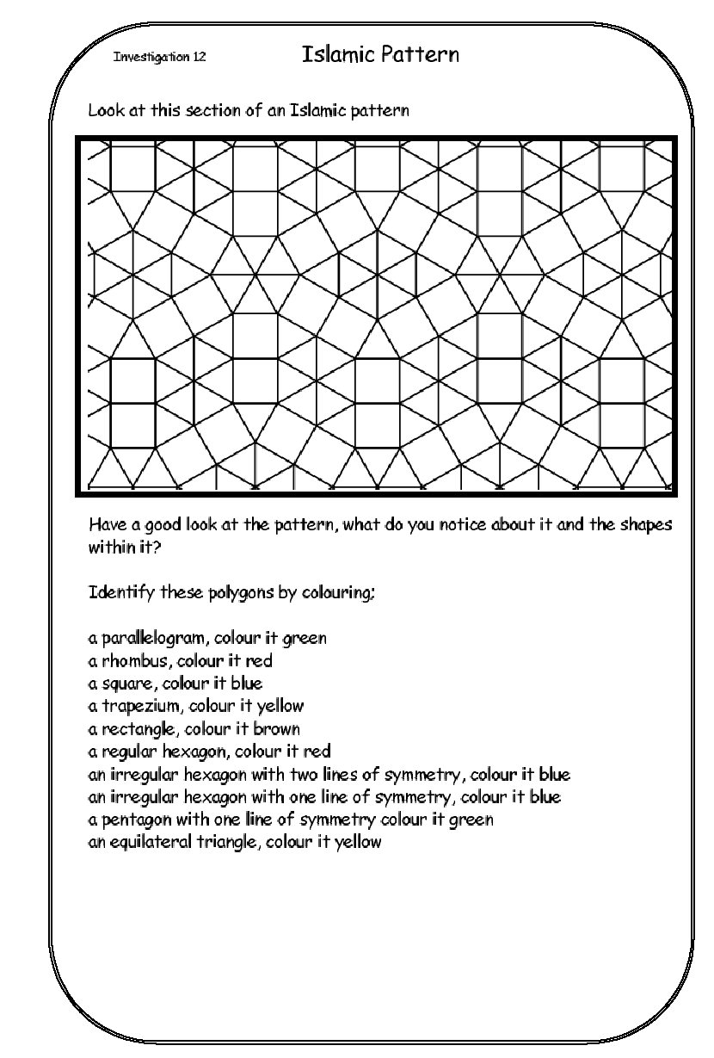

Islamic Motif
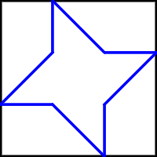
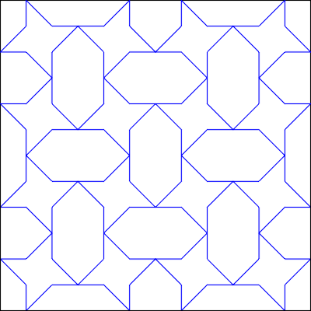
Here is one example of an Islamic motif.

Try colouring in the tile below to create a regular pattern. Use only purple, blue, yellow, red or white.

Islamic Stars
Read these instructions carefully before you start.
- Draw lines using a sharp pencil and a ruler to link the corner points of the octagon.
- Continue to draw lines at intersecting points, building up a symmetrical start pattern.
- Colour in the pattern symmetrically using red, blue, purple and yellow, leaving some areas white.
- For crisp outlines, go over ruler lines with black handwriting pen.
- Embellish with 8 sequins or foil triangles.
- Carefully cut around the outside of your octagon.

