Sikh Symbols

LI: Match the pictures of the symbols to the correct names and explanations.

Name? | 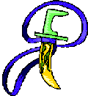1. | A type of breeches (shorts) worn by Sikhs. These were first worn by Sikh warriors hundreds of years ago.  Kirpan  Kesh  Kanga  Kara  Kaacha
Name? | 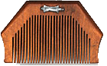2 | This bracelet has no beginning and no end – just like God, and is a symbol of being close to God.
Name? | 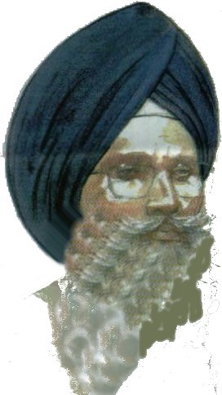3 | This symbol represents the fight against evil.  It also represents the defending the weak or people around the world.
Name? | 4 | This symbolises keeping the body clean, neat and tidy to please God.
Name? | 5 | Sikhs do not cut their hair as it is a symbol of purity and holiness.

