BETHLEHEM BUGLE  VOTED NEWSPAPER OF THE EMPIRE | $6  Sesterce
BABY BORN IN A STABLE  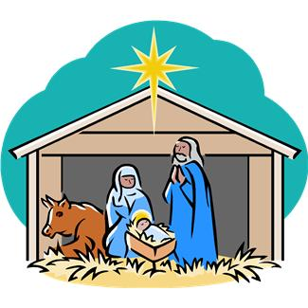 | KICK ‘EM OUT!  Join our protest against the Roman Invasion  Register now for the March on the temple  Register now on page 5  Buy a donkey banner
A shocking story was told to our reporter in Bethlehem yesterday. It seems that a young family – visiting Bethlehem for the Roman tax census – was unable to find a room in our fair city. ‘No room’ they were told by every hotel, until finally, this poor young lady gave birth in a stable.
A STABLE! The health issues alone should cause us concern. What does this say about Bethlehem when no one – no one - could find the space for one family in trouble. I have heard it said that this poor family were ‘Nazarenes’ and should go back where
For sale
One donkey
Four years old, good state of health.
Contact the seller, Mr. Joseph David in the stable at the Old Inn – Passover Street, Bethlehem

they come from. However, that is a
Government issue – the issue facing us
today is ‘charity!’ Charity begins at home
they say – and Bethlehem is our home.
Let us be charitable to strangers

