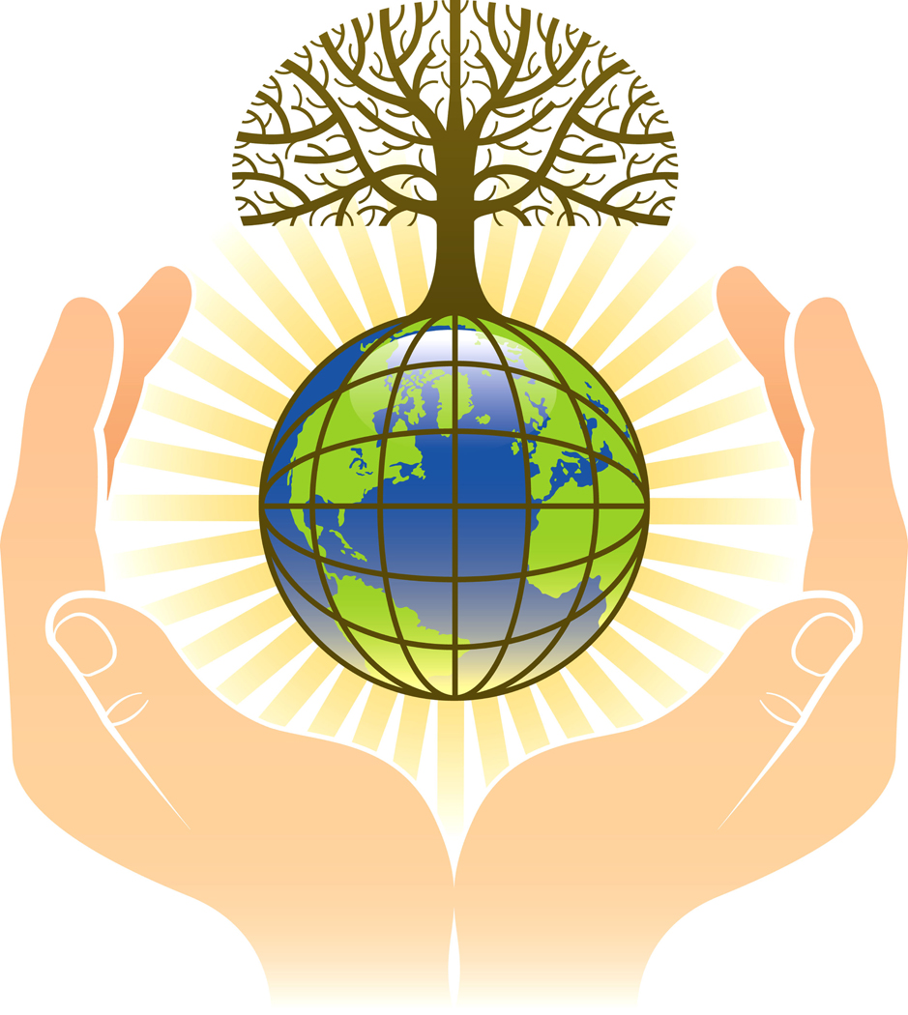
Creation in different religions
CREATION
Complete the thinking fork by adding the key teachings of each religion onto the branches.
Extension activity: What similarities and differences are there between the story of creation in different religions? What can you say about them? Write about them in your book.
CHRISTIANITY
ISLAM
JUDAISM
HINDUISM

