Barabbas is set free

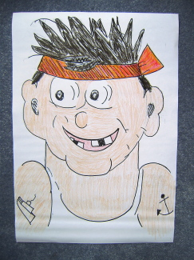
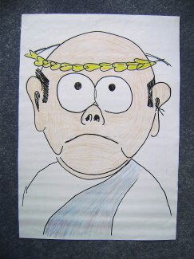
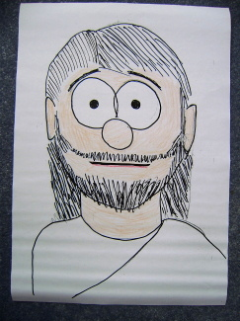

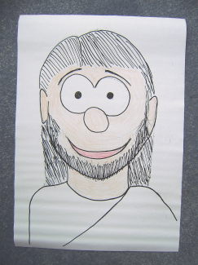

B P J1 J2

I usually have 4 children holding the pictures sitting on 4 chairs at the front, and they stand and hold up their pictures as indicated by the letters in the text.
There are 2 alternative puppet plays, one for before Easter and one for after.

B Barabbas was sitting in prison. He couldn’t see out, but he could hear the noises outside – donkeys braying, birds chirruping, the market people calling, “Buy my oranges!”, friends talking. He felt very sad because he might never see his friends again. You see, Barabbas was a robber and a murderer, and in the time when he lived, which was a very long time ago, the law said that if you killed someone, you would be put to death yourself. Now they had caught him, and he was waiting to see what would happen to him. He hoped that his friends would not get caught as well.
He was also wondering what was happening outside of the prison. It was holiday time in Jerusalem A few days ago he had heard lots of people shouting, "Hosanna! Hosanna! Long live King Jesus!” The prison guards told him that Jesus had ridden into Jerusalem on a donkey. They had all laughed. He wondered what was happening now? He had heard that Jesus had done some wonderful things. But what would Pontius Pilate think about Jesus being in Jerusalem? The Romans did not like it if anyone else talked about being a king.

B & P Now, Pontius Pilate was the only man on earth that Barabbas was afraid of. Barabbas had never been scared of anyone or anything. But Pontius Pilate was the Roman ruler in Jerusalem. He was the only person who could sentence him to death. If Pontius Pilate clicked his fingers, his soldiers obeyed instantly. If Pilate said "die", he would be led out to die.

P Pontius Pilate was eating his breakfast. He wasn't very hungry today, so he just had roast chicken, wine, toasted rice cakes and some grapes. He was just finishing his breakfast when a prisoner was dragged up to his house. Why on earth was he being disturbed so early in the morning?
P & J1 The prisoner was Jesus. They wanted Pilate to put Jesus to death. Pilate was amazed! He knew that Jesus had done nothing wrong. He knew that Jesus had ridden in to the city on a little donkey. He wasn’t dangerous! So Pilate took Jesus outside to show him to the crowds of people.
"What shall I do with your King?" he asked.
"Kill him!" "Crucify him!" all the people shouted.
Now every year, at the holiday, Pontius Pilate would set free one of the prisoners to give all the people a present. So he shouted out to the crowd, "Who shall I set free, Barabbas the murderer or Jesus your King?"
And do you know what the crowd shouted? They shouted "Barabbas!" "Barabbas!"
Pilate did not really want to kill Jesus, but he did want to make the people happy, so he sent Jesus away to die.

B Barabbas was still sitting in his prison. He was really scared now. He had heard all the crowds shouting "Kill him!" "Crucify him!” Then he heard them shouting "Barabbas!" "Barabbas!"
Then the jailer opened the door. Barabbas felt his heart pounding. But the jailer said to him, "You're going free. Don't ask me why. They are crucifying Jesus instead of you. Get out of here".
So Barabbas got out straight away. He ran away from there as fast as he could and went to look for his friends.

J2 Three days later, after Jesus had died and then come alive again, Jesus went to find His friends. Jesus’ friends were all together. They were very sad and very scared without Jesus. And then suddenly Jesus was there with them in the middle of the room. You can't imagine how they felt. They were so amazed and delighted and full of joy and astounded to see him. Jesus had been dead and now he was alive!

P Three days later, Pilate started to hear rumours. He heard that people were saying that Jesus was alive. He did not know whether it was true or not. He did not really care. But he hadn't really wanted to kill Jesus. He quite liked Him really. Perhaps Jesus was alive? Perhaps Jesus really was a King?

Puppet (before Easter)

Lucy: Was Barabbas a bad man?
Ruth: Yes. He was a robber and he had killed people
Lucy: So ….. why was he set free, and Jesus was punished?
Ruth: Jesus died instead of him, didn’t He?
Lucy: That was very kind of Jesus. But it wasn’t fair, was it?
Ruth No, Jesus shouldn’t have been killed, He didn’t do anything wrong.
Lucy: And what about that Roman man, P..P..P what was his name?
Ruth: Pontius Pilate
Lucy: Yeah, him? Why didn’t he just say ‘no’?
Ruth: Because all the crowds of people were shouting about Jesus "kill him", "kill him," and Pontius Pilate wanted to do what the crowd said. But shall I tell you something very special?
Lucy Yep, what is it?
Ruth: It was all part of God’s plan! Jesus knew that God had a plan. Jesus was trusting God to raise Him up from the dead
Lucy: So that’s how Jesus came alive again?
Ruth Yes, and He is alive for ever!
Lucy Yeah, always and for ever!
Ruth: Jesus’ friends were happy when they saw Him, weren’t they?
Lucy: And Barabbas was happy too
Ruth: Yes, because he was free!
Lucy: Do you think he started to be good afterwards?
Ruth I don’t know, but I hope so.
Lucy And wasn't it amazing, Jesus went straight to see his
friends?
Ruth: Well, that's what you would do, isn't it? If you got some good news, or something exciting was happening, you’d go straight to tell your friends, wouldn’t you?
Lucy: Yeah, and Jesus was happy because He was alive again! And I am happy too! Yeah!

Thinking time
It's great news that Jesus is alive for ever. It is the best news! Just think about how Barabbas must have felt to know that Jesus had taken his place. Jesus was the best friend of all to Barabbas. Now Barabbas had a chance for a new start.

Prayer
Thank you God / that You are our Friend./ Thank You for all our friends. / Help us all to be good friends. / Amen

Alternate Puppet Play (for after Easter)

Lucy: I’ve finished all my Easter eggs!
Ruth: What, you've finished all your chocolate already?
Lucy: Ye..e..e..ss. But do you know what I was thinking?
Ruth: What?
Lucy: It would be nice if Easter eggs were filled with chocolate right
the way through to the middle, wouldn’t it?
Ruth But they’re not, are they?!
An Easter egg is empty isn't it?
Lucy Just like the cave? An Easter egg is like the cave that they put Jesus in, isn't it?
Ruth: Yes, that's right!
Lucy: And the cave was empty!
Ruth Yes, that’s right. Jesus wasn’t in it because He was alive again!
Lucy And wasn't it amazing, that Jesus went straight to see his
friends?
Ruth: Well, that's what you would do, isn't it? If you got some good news, or something exciting was happening, you’d go straight to see your friends, wouldn’t you?
Lucy: Yeah. Friends are nice. (I’m glad that I’m a friend of Jesus too!)

Thinking time
It's good to be with friends, isn't it? It's good to be with people that you feel comfortable with, that you can talk to and that you can have fun with. And it's good to choose friends who help you. Barabbas had a bunch of friends who all got each other into trouble. But now Barabbas had a chance for a new start. Perhaps he, and all his friends, decided to start living better. God wants to be your friend.

Prayer
Thank you God / that You are our Friend./ Thank You for all our friends. / Help us all to be good friends. / Amen

