Islam Quiz

- Islam is a type of what? R

- Was Mohammed a prophet or a God?

- How many Pillars of Islam are there?

- A person who follows Islam is called a M ?

- Christian’s holy book is called the Bible. What is the holy book of Muslims? Q

- In Islam how many Gods are there?

- In Islam what is God’s name? A

- Before a Muslim touches a Quran what do they wash?

- What does the Quran sit on when being read?

10.What language is the Quran written in? A

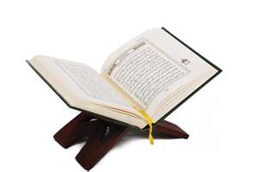
Islam Quiz

- What is the second pillar of Islam? P

- What is the Muslim place of worship called? M

- What three things does a Mosque building usually have?

- What does a Muslim take off once inside the mosque? s

- What is wudu?

Islam
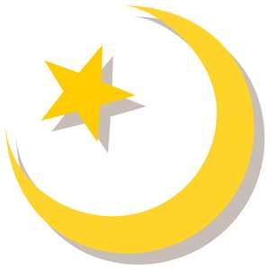
- Find the missing words

- Islam is one of many kinds of .
- People who follow Islam are called .
- The Prophet was the man who spread the word of Islam to the people.
- Mohammed was born in the city of .
- Muslims call God .
Mohammed Allah religion Mecca Muslims

- Mohammed is an important person to Muslims. Who is important to you? Draw a picture of them.

