Name_________________________ Date_________________________

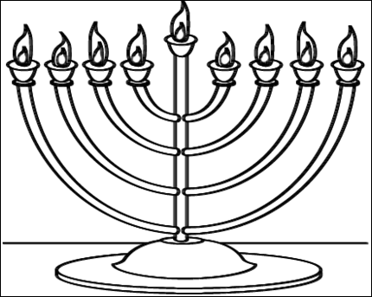
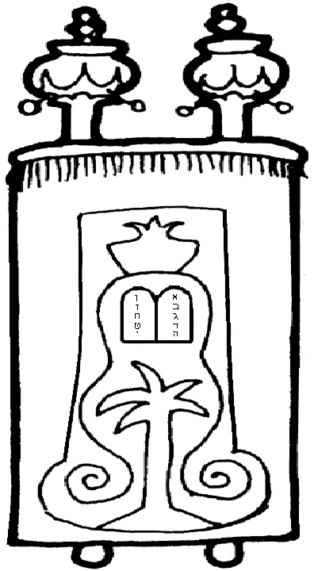
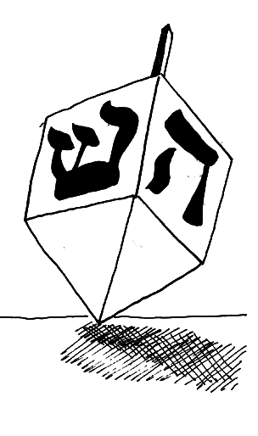
Judaism
Colour the Menorah that is also sometimes called a Hanukiah.
Decorate the Torah Scrolls cover.
What is this called and what is it used for?
________________________________________________________________________________________________

