

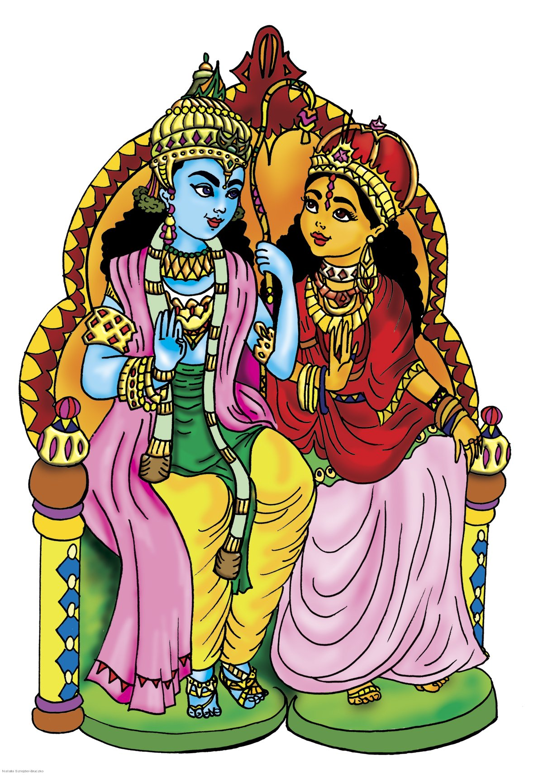
Finally, after the battle was over, Rama and Sita returned home and everyone celebrated.

In the beginning, Prince Rama was banished to live in the forest. Sita his wife and Lakshmana his brother went with him.

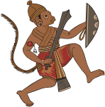
Fortunately, Hanuman the monkey king
helped Rama fight the demons.

They encountered the demon king Ravana, he saw Sita and thought " I want her to be my wife".

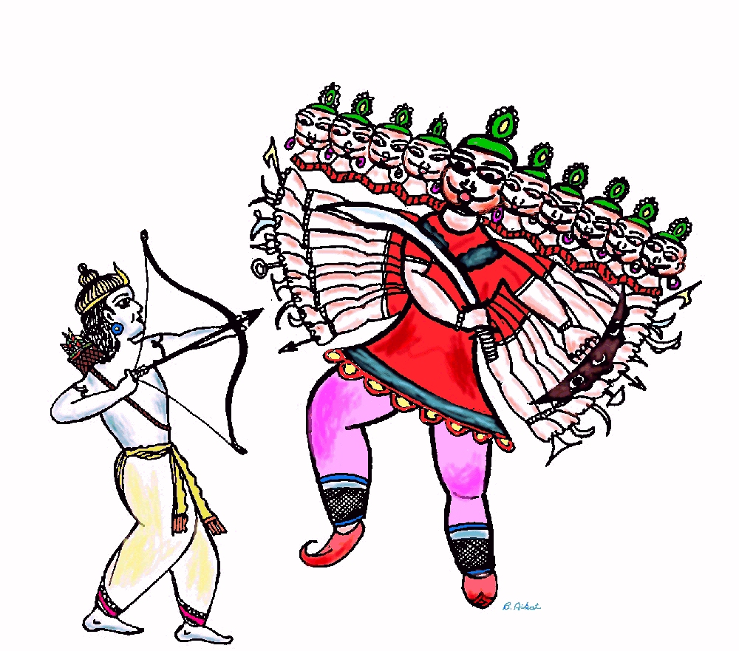
Although the brothers tried to keep Sita safe, she was tricked and eventually Ravana caught her.

