Name ________________________ Date __________________
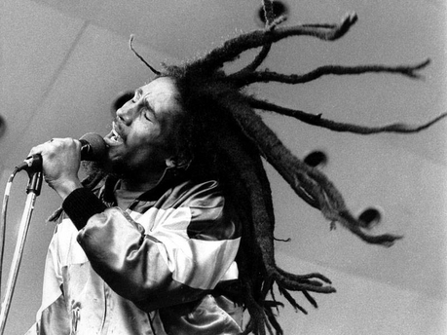
Rastafari
There are around _______ _______________ Rastafarians in the world though most live in _________________. They believe they should not cut their ____________ and so often grow it into _________________________. Many Rastas do not eat pork and some are even _________________.
The symbol of Rastafarianism is a ____________ and the flag is red, green and _____________________.
Bob ________________ was a reggae musician and much of his music told the world about ideas from Rastafarianism.
Draw the rastafari flag here:
Word bank
Jamaica vegans hair
one million dreadlocks
Marley lion yellow

