The Destruction of the Temple and The Western Wall

The holiest place in Judaism was the Temple, which was built on Mount Moriah in Jerusalem. For hundreds of years, Jews believed that it was the only place where they could worship God properly. It took seven years to build and was one of the most splendid buildings in the world. It was destroyed by the Greeks.

A second Temple was built in the same place but this Temple was burnt to the ground by the Romans. They knew that the Temple was very important to the Jews and this was why they wanted to destroy it. All the gold and silver Temple treasures were taken to Rome. Only the Western Wall of the huge raised platform on which the Temple had stood remained. The Western Wall is sometimes known as the Wailing Wall. People go there to pray and to feel close to God. They push pieces of paper between the holy stones. These pieces of paper have their prayers and hopes written on them.
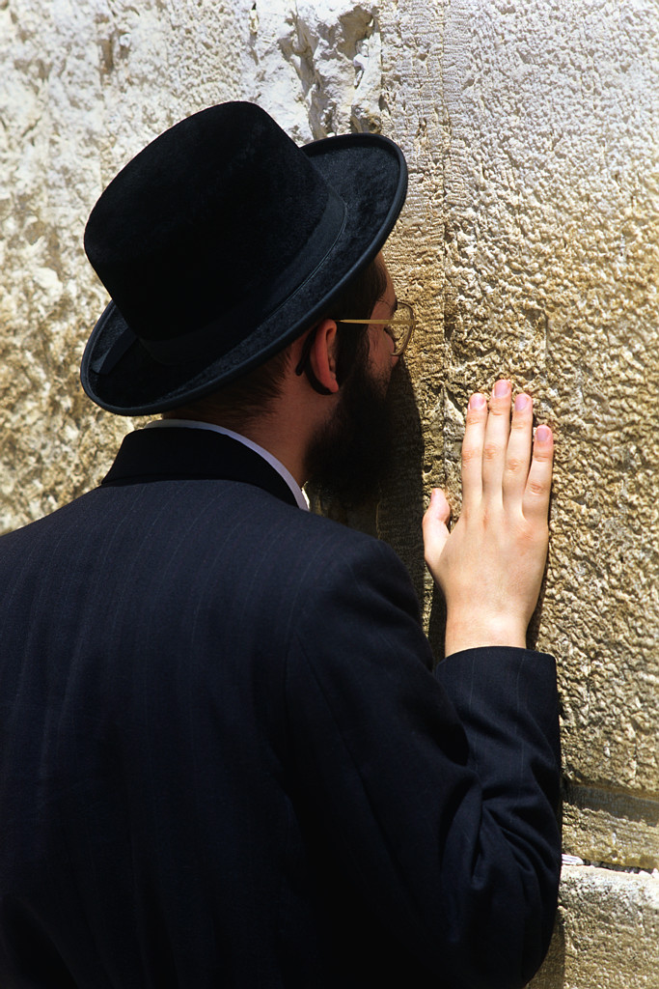

Tasks

- Draw a wall of about 8 large bricks in your book. Write one of your hopes for the future on each of these bricks. Try not to make them all about you.

- Write and illustrate a prayer of hope for the future.

