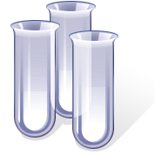
What do we want to find out?

What will change?
What did we do?
What will we need?
What will stay the same?
What happened?
What have we found out?

