Circuits & symbols

Can you label these symbols?
__________

__________

__________

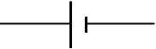

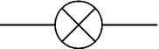

Look at the following circuits. Can you work out how many of each component is in each circuit?
There are

There are

There are
There are

