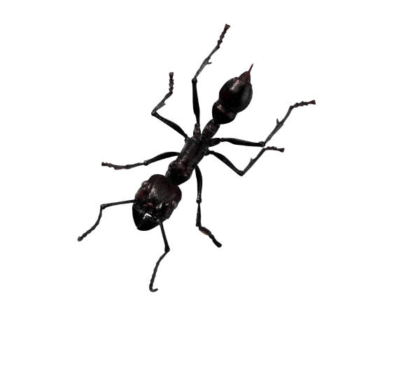
Insect/minibeast Carroll diagram.

Has 6 legs Does NOT have 6 legs

Has
wings

Does
NOT
have
wings
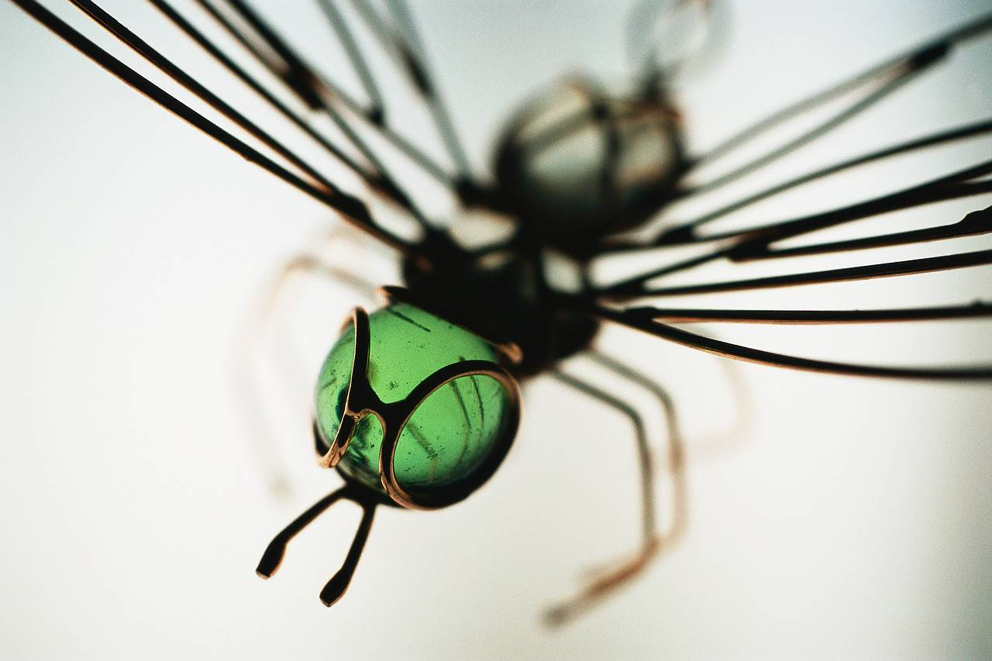
Make your own insect/minibeast Carroll diagram.
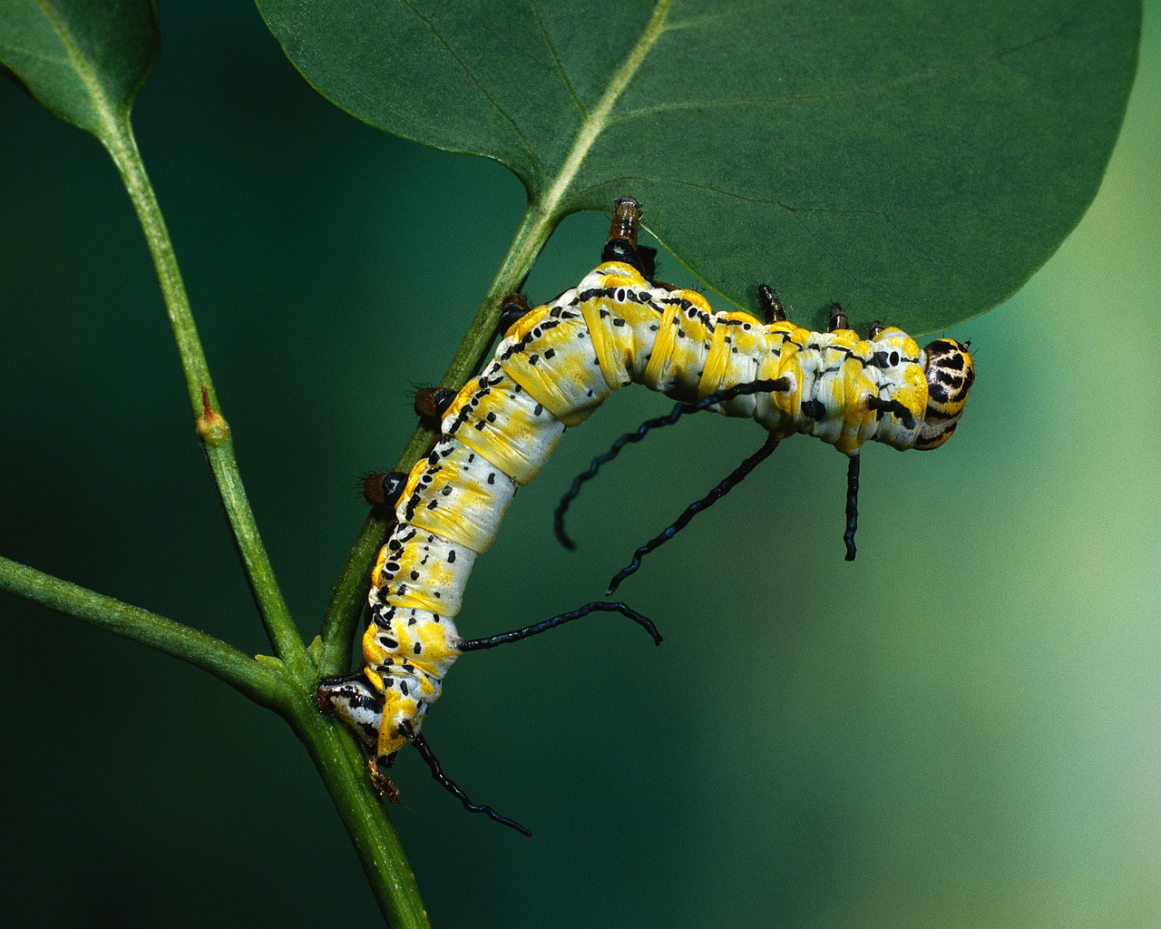
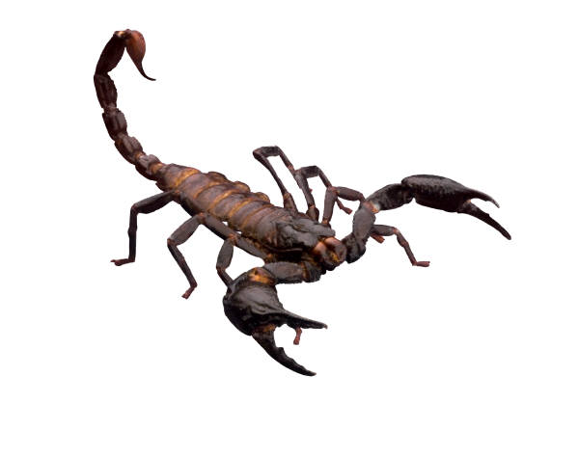
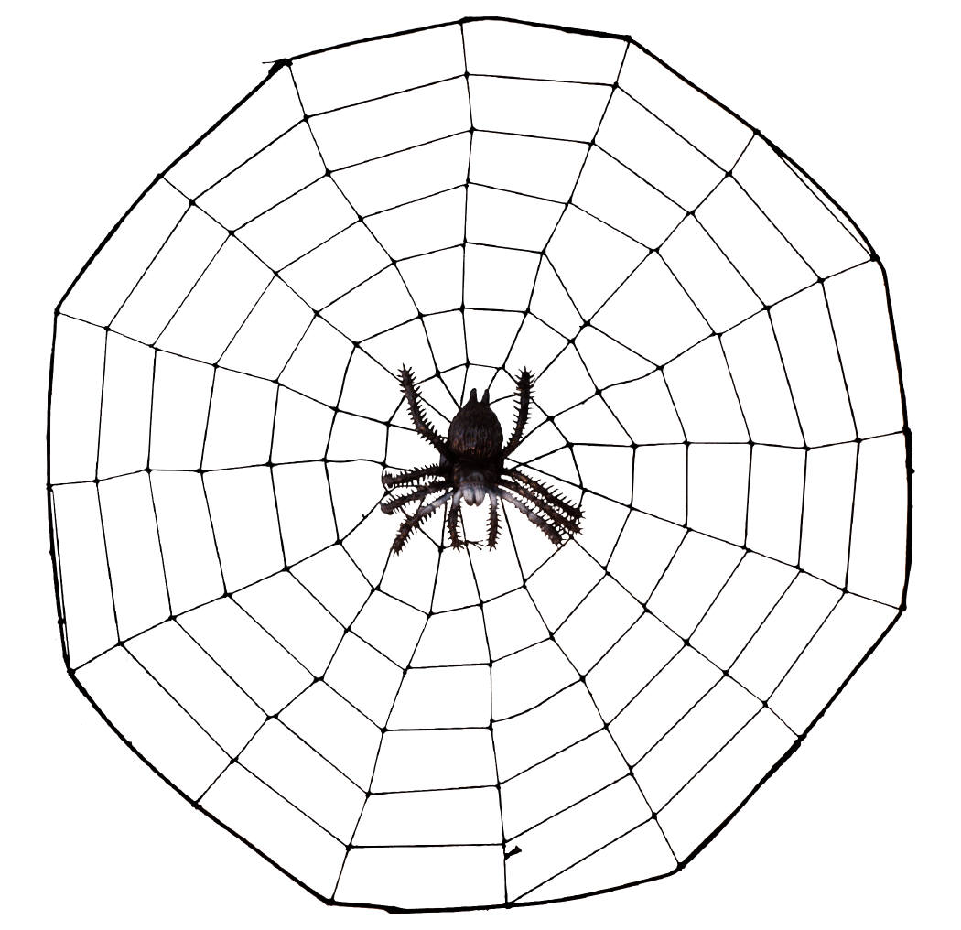
Use these pictures to help you make your own Carroll diagram. What groups will you use?

