Variation

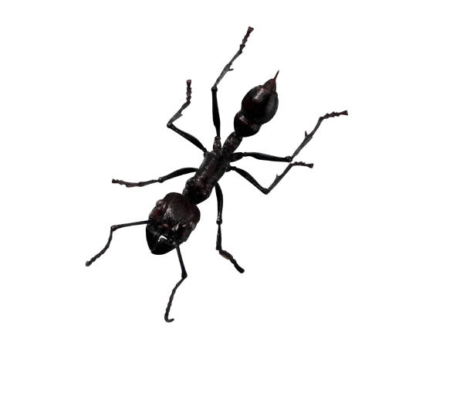
elephant bee robin ant cobra frog ivy

cat daisy shark daffodil newt goldfish man

Separate into two groups.
Group title:
Group title:

Now separate the animals into six groups.
Group title:
Group title:
Group title:
Group title:
Group title:
Group title:

