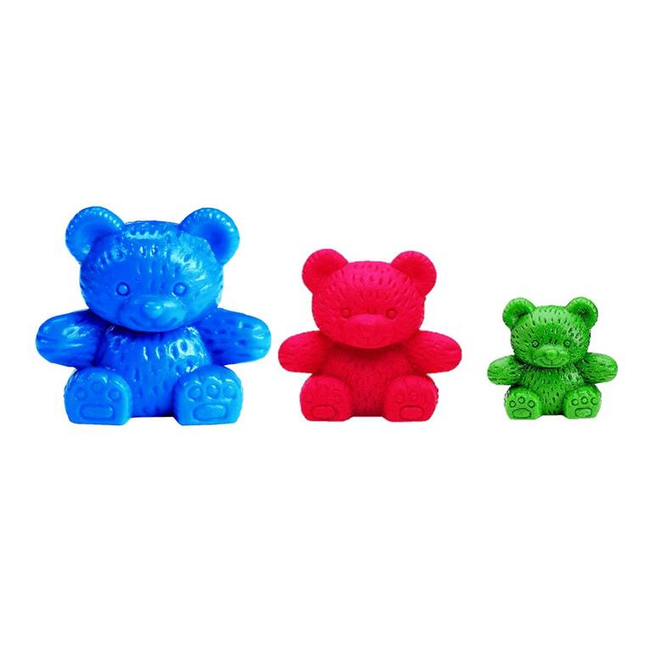
Dear Class 3,
Hello my name is Compare Bear, have you seen me in your Maths area?
I’m feeling a little bit bored today. What I would really like to do is go for a sail around Washing Up Bowl Lake. The only problem is that I haven’t got a boat.
I was wondering if you could test some different materials for me and let me know which is the best one for making a boat.
Thank you so much
Love Compare Bear x

I can make predictions
I can record what I have observed with support / independently
Object | Do you think it will make a good boat? | Did it make a good boat?

Dear Compare Bear,
The best thing to make your boat from is _________________________because _______________________________________
Love from

