
Crime
Scene
Investigation

My Investigation Booklet
Crime Scene Investigator__________________________________

Crime Scene Notes
Upon entering the premises I observed the following__________________________________________________________________________________________________________________________________________________________________________________________________________________________________________________________________________________________________________________________________________________________________________________________________________________________________________________________________________
Questions I need To Ask

My Case Notes
Test 1
What am I going to test ?

What will I need ?

What will I do ?

What did I notice?

What conclusions can I make from what I have observed ?

My Case Notes
Test 2
What am I going to test ?

What will I need ?

What will I do ?

What did I notice?

What conclusions can I make from what I have observed ?

My Case Notes
Test 3
What am I going to test ?

What will I need ?

What will I do ?

What did I notice?

What conclusions can I make from what I have observed ?

My Case Notes
Test 4
What am I going to test ?

What will I need ?

What will I do ?

What did I notice?

What conclusions can I make from what I have observed ?

My Case Notes
Test 5
What am I going to test ?

What will I need ?

What will I do ?

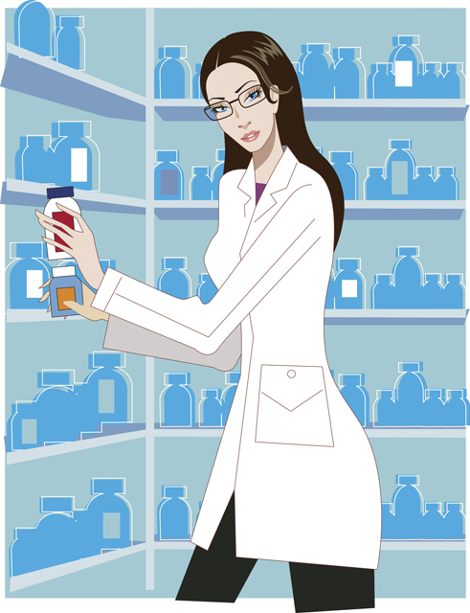
What did I notice?

What conclusions can I make from what I have observed ?

My Case Notes
Test 6
What am I going to test ?

What will I need ?

What will I do ?

What did I notice?

What conclusions can I make from what I have observed ?

I think the mystery material is ________________________
Because ____________________________________________________________________________________________________________________________________________________________________________________________________________________________________________________________________________________________________________________________________________________________________________________________________________
Essential Vocabulary I have learned

