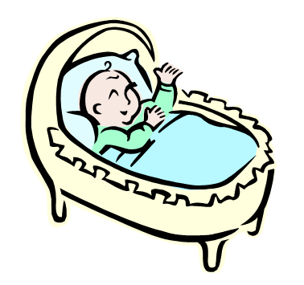

Name ________________________________________________
Primary School
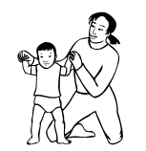
Name _________________________________________ Date __________________________

We Change As We Grow Up

1 | 2 | 3
4 | 5 | 6

