How We See Things

Light comes from a light ___________, and travels in a ______________ line.

When it hits an object, the light sc______________, b_____________, or goes

th_________ it. Shadows are formed when something ______________ the light.
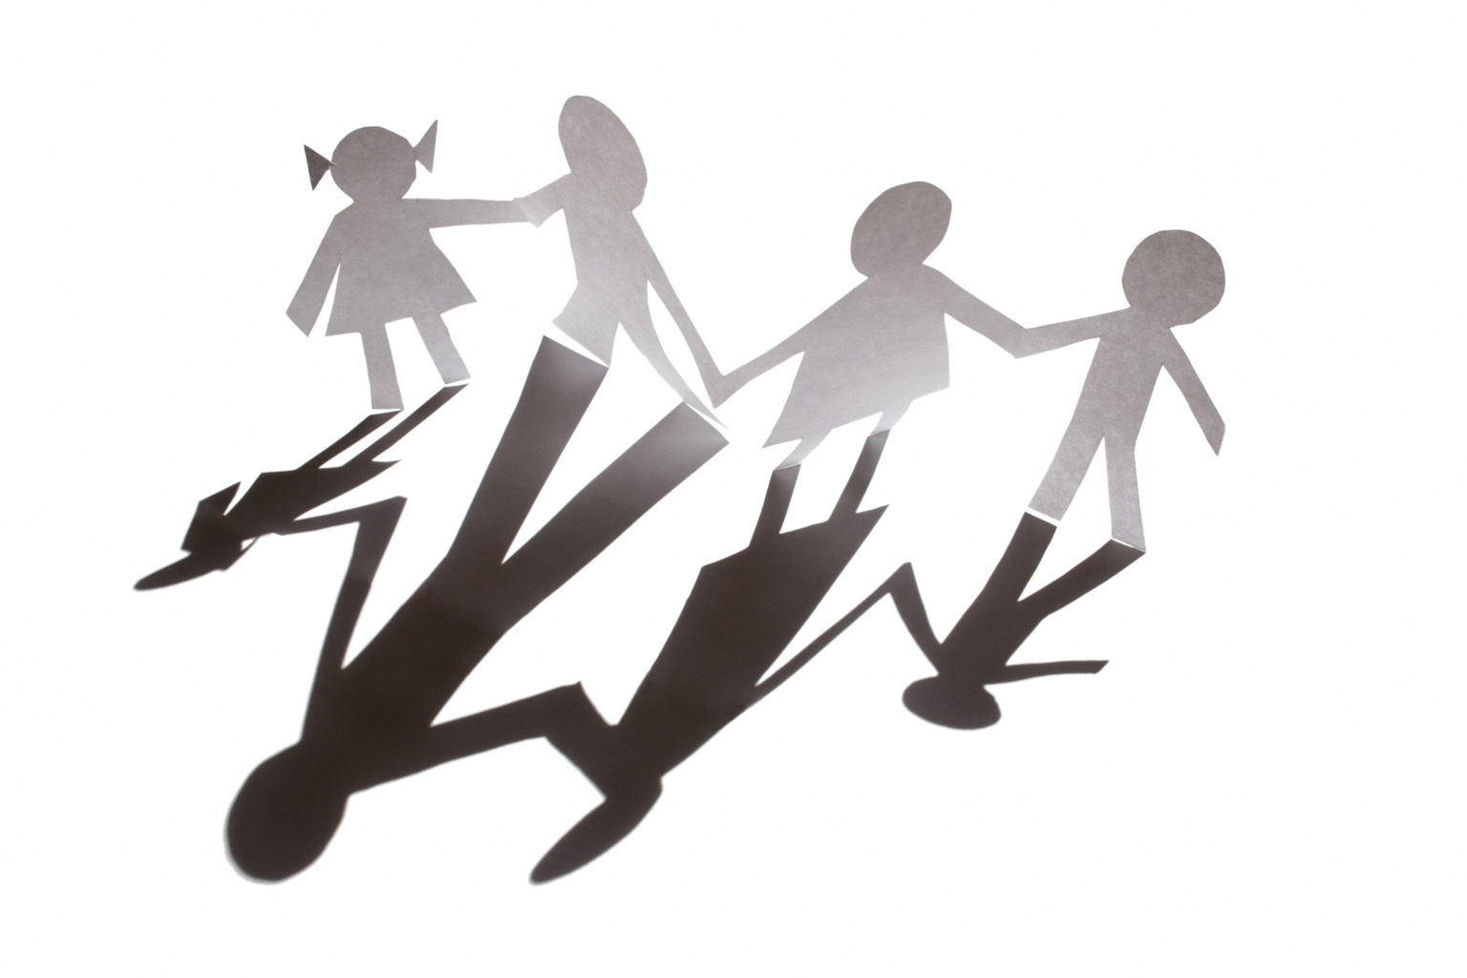

Materials that block the light are called _______________. When we see things,

____________ enters our eyes.

blocks through bounces opaque
scatters source straight light

Draw and label a diagram below, including these things:

pupil, eye, light beam, light source, object, light ray bouncing off the object

How We See Things

In your science books, answer these questions in complete sentences. (Don’t forget to put a date and a title before you begin.)

- How does light travel?

- What words do we use to describe where light comes from?

- When light hits an object, what are the three things that can happen?

- Explain how shadows are formed (don’t forget to use the correct scientific word to describe the kind of material.) You can draw a diagram if you wish.

- Explain how we see things (draw and label a diagram, including these things: pupil, eye, light beam, light source, object, light ray bouncing off the object.)

Some helpful words

Straight line light source opaque blocks through

bounces scatters source straight

How We See Things

In your science books, write and complete these sentences. (Don’t forget to put a date and a title before you begin.)

- Light travels…

- The words that we use to describe where light comes from are …

- When light hits an object, the three things that can happen are …

- Shadows are formed when… (draw a diagram if you wish.)

- We see things when … (draw and label a diagram, including these things: pupil,
eye, light beam, light source, object, light ray bouncing
off the object.)

Some helpful words

Straight line light source opaque blocks through

bounces scatters source straight

