Object | Material | Thermal Insulator/Conductor | Why?
kettle | Plastic | Insulator | To stop people burning themselves when they touch the kettle.

baby spoon
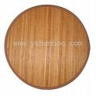
table mat

spatula
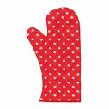
oven glove

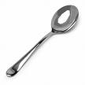
serving spoon
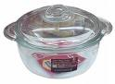

Oven dish
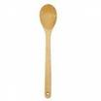

Wooden spoon
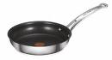
Frying pan

