Man made or natural rocks?

What does man made mean? (The clue is in the name)

What does natural rock mean?

Sort these rocks into groups depending on whether they were man made or natural rocks.
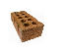
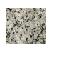
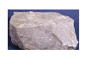
Brick Granite Limestone

Marble Concrete slab Slate


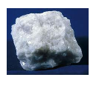
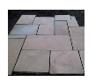

Man made rocks
Natural rocks

Rocks are very important and we couldn’t do without them. Can you think of some objects that are made out of rocks?

http://www.bbc.co.uk/learningzone/clips/rocks-and-soil/2208.html

Watch the video clip. What other uses do rocks have?

