Aim - Match the habitat to their features

Under your aim and date cut and paste the habitats with the correct features:

Ocean – cold, salt water, many predators | Artic – very cold, snow and ice, little shelter | Rain forest – very hot, damp and many plants & trees
Woodland – can be cold in winter, many plants and trees | Meadow – little shelter, lots of grass to eat | Mountains – very cold higher up, little shelter
Swamp – damp, marshy, with many different plants | Desert – very dry, hot in the day, cold at night, little shelter | Pond/lake – sheltered water is calm, many places to hide

Aim – find out how an animal is best suited to its habitat

Match the animal to what makes it best suited to its habitat, stick these in your science book under the aim and date:

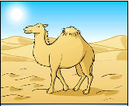
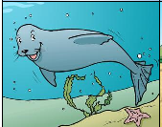

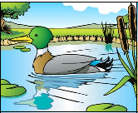
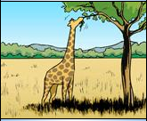

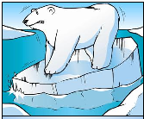
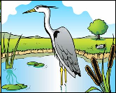

Thick fur | flippers | Long neck
Long beak | Hump to store fat | Webbed feet
Now draw your own animal and label how it is adapted to its habitat!

