The Functions of the Parts of a Flower

ANTHER |  | Female part, sticky and collects the pollen.
CARPEL |  | Male part, holds up the anther.
FILAMENT |  | Female part, tube that the pollen travels down.
STIGMA |  | Male part, produces pollen.
STYLE |  | Female part of the flower.
STAMEN |  | Female part, where egg cells are fertilised and turn into seeds.
OVARY |  | Male part of the flower.

LIFE CYCLE OF A FLOWER

The brightly coloured petals, the scent and the nectar attract insects such as bees to the flower.
The bee accidentally transfers pollen onto the female part, the sticky stigma. This is called POLLINATION.
The fertilised egg cells turn into seeds. This is called SEED PRODUCTION.
The pollen grains travel down from the stigma and through the style into the ovary.
The bees crawl around inside the flower, looking for the nectar and accidentally get covered in pollen from the male part, the anther.
Inside the ovary are ovules (egg cells) which the pollen fertilises. This is called FERTILISATION.
Once the seeds have been made, the flower needs to scatter them about on the ground. This is called SEED DISPERSAL.
Once the seeds have been dispersed into the ground, anther flower will grow.
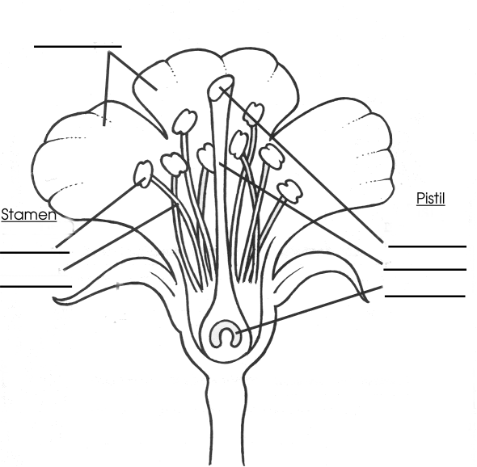

The Parts of a Flower

A flower has both __________ and

_____________ parts. The male part

is called the _____________ and the

female part is called the ___________.

The male part is made up from the

________________ and the

_______________. The female part is

made up from the ______________,

_________________ and the

________________.

The Parts of a Flower

A flower has both m__________ and

f_____________ parts. The male part

is called the s_____________ and the

female part is called the c__________.

The male part is made up from the

a________________ and the

f_______________. The female part

is made up from the s____________,

s_________________ and the

o________________.

