Seeds are planted in the ground.

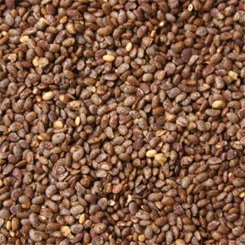
Stems and leaves grow up above the ground.

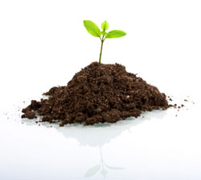
Flowers grow on the stems.

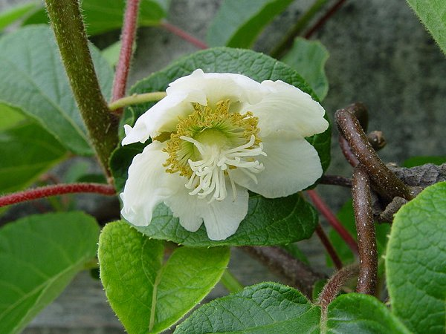
Fruits are formed from the flowers.

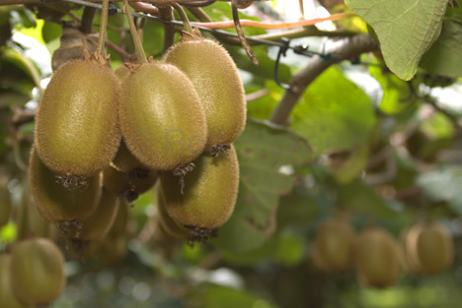

Seeds grow within the fruits.

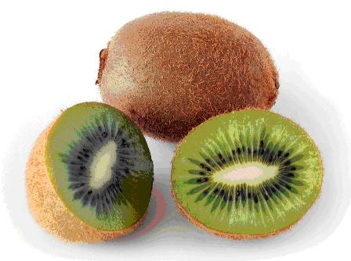

Roni Benavides - St.Joseph’s Catholic School 2009

