I wonder which rocks are permeable?
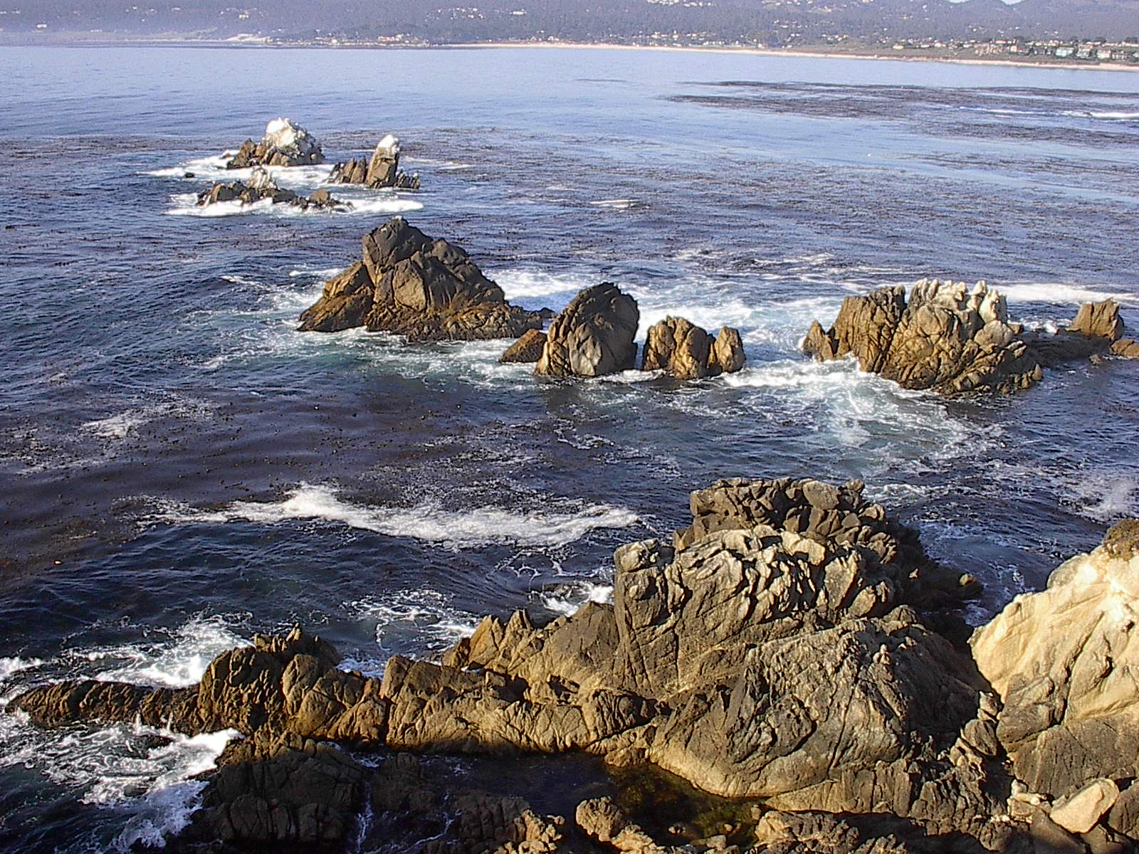
Prediction
I think …………………………………………………………………………………………………………
………………………………………………………………………………………………...

Fair test
To make my test fair I will ……………………………………………………………
……………………………………………………………………………………………………………..
……………………………………………………………………………………………………………..

What I am going to do
…………………………………………………………………………………………………………………………………………………………………………………………………………………………………………………………………………………………………………………………………………………………………………………………………………

Results

- - permeable (soaks through) X - impermeable (does not soak through)

Rock | Will water soak into these rocks?

What I found

I found that ………………………………………………………………………………
………………………………………………………………………………………………………………………………………………………………………………………………………………………………………………………………………………………………………
…………………………………………………………………………………………………
…………………………………………………………………………………………………
…………………………………………………………………………………………………
…………………………………………………………………………………………………
…………………………………………………………………………………………………
…………………………………………………………………………………………………
…………………………………………………………………………………………………

