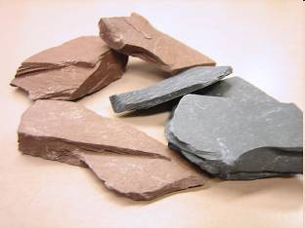
Rock Fact File

Name of rock:____________________
_______________________________
Texture:________________________
_______________________________
Appearance:______________________
_______________________________

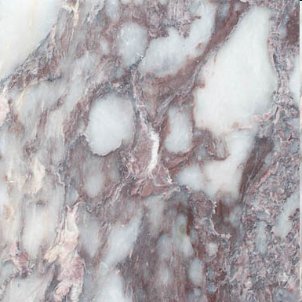
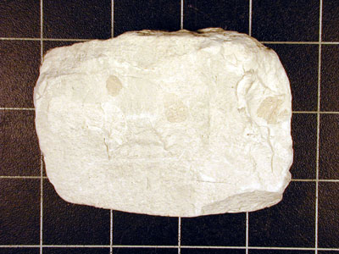

Name of rock:____________________
_______________________________
Texture:________________________
_______________________________
Appearance:______________________
_______________________________

Name of rock:____________________
_______________________________
Texture:________________________
_______________________________
Appearance:______________________
_______________________________
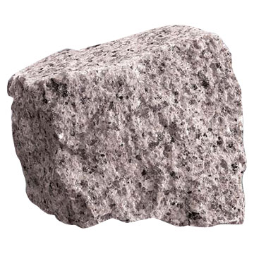
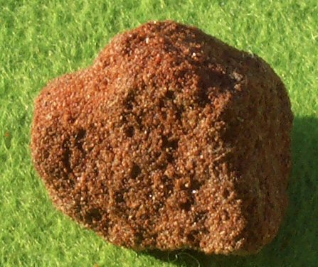
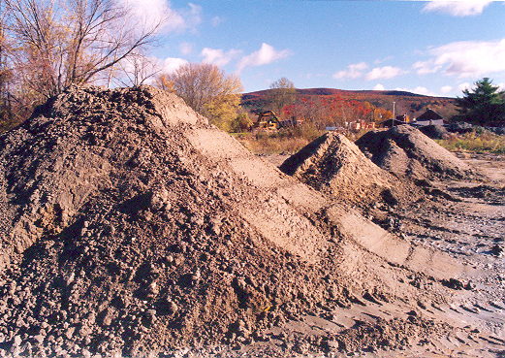
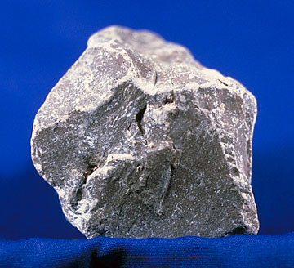

Name of rock:____________________
_______________________________
Texture:________________________
_______________________________
Appearance:______________________
_______________________________

Name of rock:____________________
_______________________________
Texture:________________________
_______________________________
Appearance:______________________
_______________________________

Name of rock:____________________
_______________________________
Texture:________________________
_______________________________
Appearance:______________________
_______________________________

Name of rock:____________________
_______________________________
Texture:________________________
_______________________________
Appearance:______________________
_______________________________
Words you might need… (you can add some of your own)
Name of rock:

- Granite
- Limestone
- Chalk
- Clay
- Marble
- Slate
- Sandstone

Texture:

- Dusty
- Flaky
- Rough
- Smooth
- Sharp
- Sandy
- Cold

Appearance:

- Grey
- Black
- White
- Brown
- Swirly
- Spotty

Rock Factfile

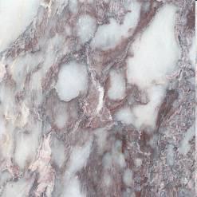

Name of rock:____________________
_______________________________
Texture:________________________
_______________________________
Appearance:______________________
_______________________________
Purpose:_________________________
_______________________________

Name of rock:____________________
_______________________________
Texture:________________________
_______________________________
Appearance:______________________
_______________________________
Purpose:_________________________
_______________________________
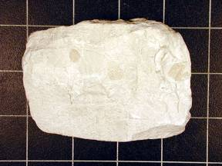
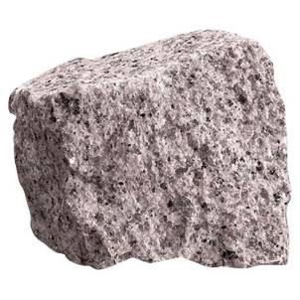
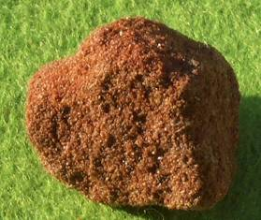

Name of rock:____________________
_______________________________
Texture:________________________
_______________________________
Appearance:______________________
_______________________________
Purpose:_________________________
_______________________________

Name of rock:____________________
_______________________________
Texture:________________________
_______________________________
Appearance:______________________
_______________________________
Purpose:_________________________
_______________________________

Name of rock:____________________
_______________________________
Texture:________________________
_______________________________
Appearance:______________________
_______________________________
Purpose:_________________________
_______________________________
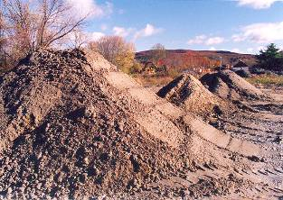
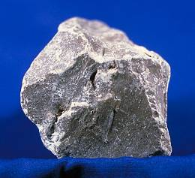

Name of rock:____________________
_______________________________
Texture:________________________
_______________________________
Appearance:______________________
_______________________________
Purpose:_________________________
_______________________________

Name of rock:____________________
_______________________________
Texture:________________________
_______________________________
Appearance:______________________
_______________________________
Purpose:_________________________
_______________________________
Words you might need… (you can add some of your own)
Name of rock:

- Granite
- Limestone
- Chalk
- Clay
- Marble
- Slate
- Sandstone

Texture:

- Dusty
- Flaky
- Rough
- Smooth
- Sharp
- Sandy
- Cold

Appearance:

- Grey
- Black
- White
- Brown
- Swirly
- Spotty

Purpose

- buildings
- roofs
- making pots
- fireplaces
- writing
- paths
- kitchens

