Name:__________
Date: _______________

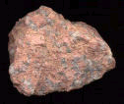
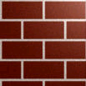
Rocks as Natural Material
A small piece of granite
Bricks

Look at these 2 different types of rock.
Now answer these questions.


- Could you find both of these rocks in the ground?
______________________________________________

- If you had lived in the Stone Age do you think you could have found both in the ground?
______________________________________________

- One of the rocks has been made by people - it is manufactured. Which one do you think it is?
______________________________________________

- What do you think the manufactured material is made from?
______________________________________________

- Where does rock come from?
_______________________________________________
_______________________________________________

- Where does soil come from?
______________________________________________
______________________________________________

