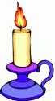
Name -
Date -

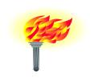
Now that you have discussed what these words mean, write down the meaning of each of them.

Transparent –

Translucent –

Opaque -

What are you trying to find out in this experiment?

Material | Transparent |  | Translucent |  | Opaque
Material | Predict | Result | Predict | Result | Predict | Result
Wood

Tissue paper

Book

Glass window

Cloth

What did you find out after doing this experiment?

What other materials would you like to test when you get home?

