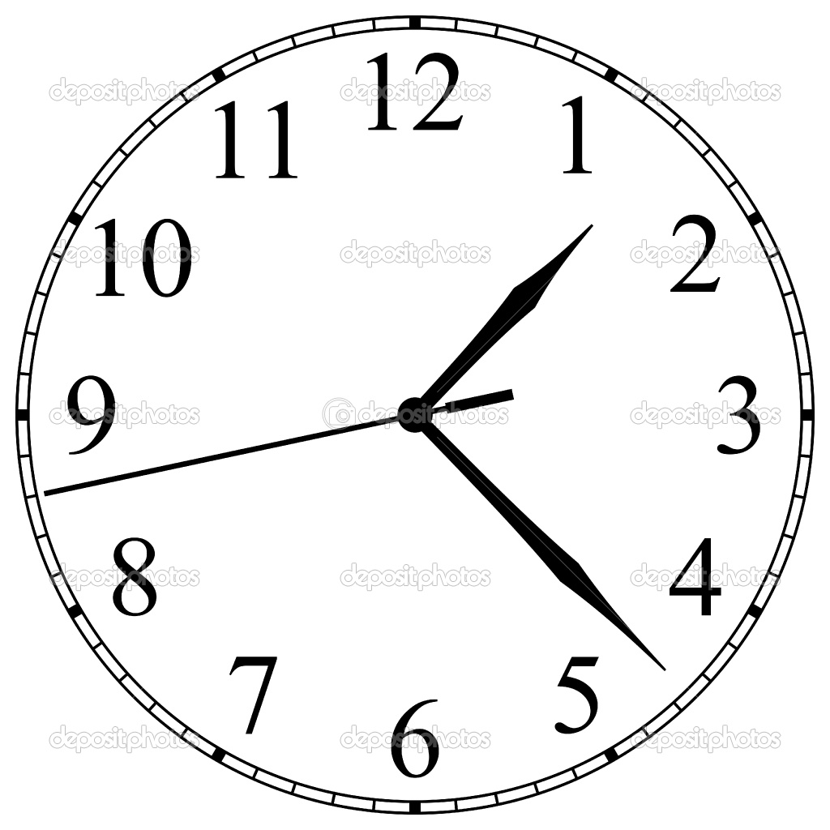
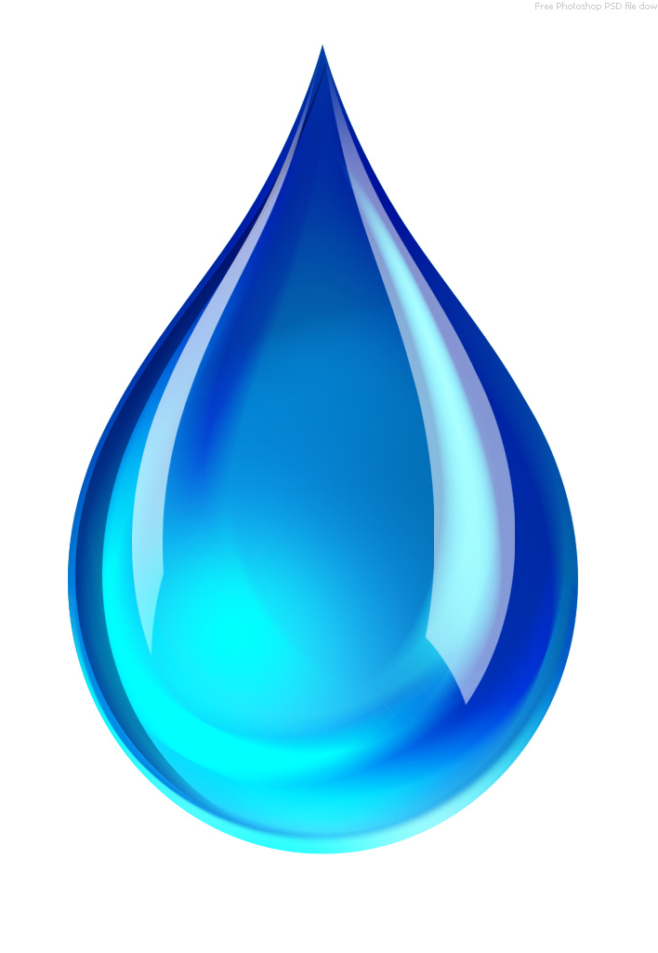
We are going to change 1 thing in each group

The amount of water
These things I will keep the same (fair testing):

Type of cup
Liquid I use
Size of the hole
How I record my results
The amount of water our group is using is:

My prediction:
I think that our cup will take this long to drain:

A few seconds 1 Minute 2 minutes more than
2 minutes

Our Experiment looked like this:

Our result:
Our cup took this long to drain:

Test | Action
Hold the cup.  Put a finger on the hole to block it | 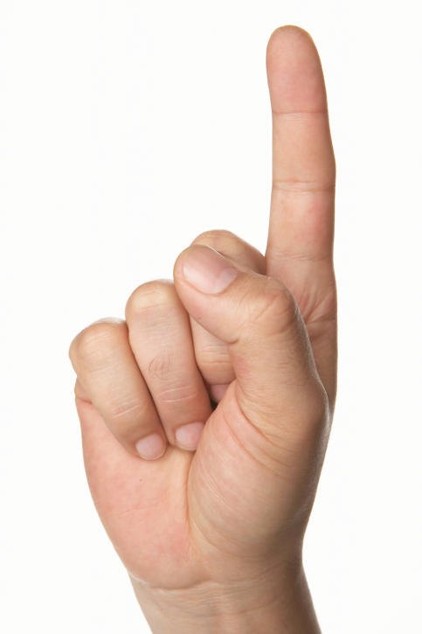  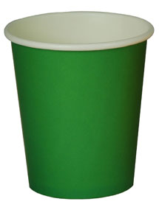
Fill your cup with water  up to the line | 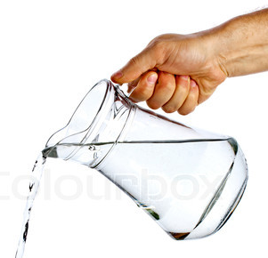
Take your finger off the hole and time how long it takes for all the water to disappear. | 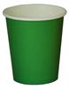  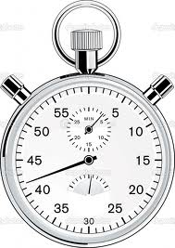  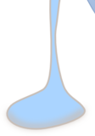

Our class results:
The ___________________________ was the best nightlight.
This is because

