Solids and Liquids.

Draw what happens as it
gets warmer.
This is a cube of ice

When ice gets warm it begins to .

When ice melts it turns to .

If you put water into a freezer it turns into a

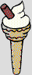

This ice-cream will melt if it gets too .

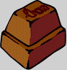

The sun has melted my bar of chocolate.

I could put it in a place to make it go solid again.

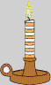
When you burn a candle it gets .

The wax will begin to .

Candle wax when it gets hot.

Gold is a .

It can be to change it to a liquid so it can be poured into a new shape.

When it cools it will be a again.

