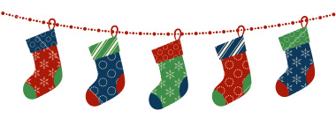

C__________________________________________________________
H __________________________________________________________
R __________________________________________________________
I ____________________________________________________________
S ___________________________________________________________
T ___________________________________________________________
M __________________________________________________________
A __________________________________________________________
S ____________________________________________________________

S_________________________________________________________
A________________________________________________________
N________________________________________________________
T_________________________________________________________
A________________________________________________________

S__________________________________________________________
N_________________________________________________________
O_________________________________________________________
W________________________________________________________
M_________________________________________________________
A__________________________________________________________
N__________________________________________________________

