
Spend £5.00
Can you pay for your Christmas dinner?
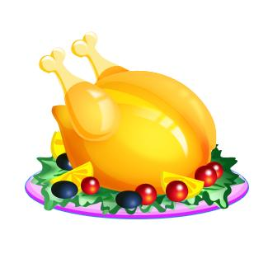




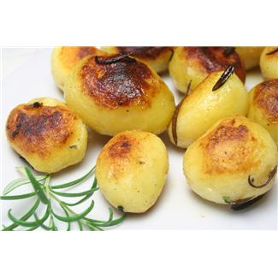


15p
45p
12p
18p
52p
35p
24p
14p
£1.00 = 100p
Add up all the items
– do you have enough?
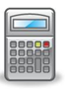
Thinking Skills
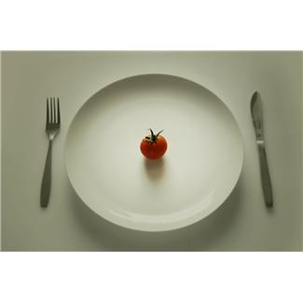
CHRISTMAS DINNER

