My Christmas 2014 by ______________
Draw your Christmas Day here.

Best present I received was … _____________________________________________________________________________________________________________________________

Who I saw over Christmas ...
______________________________________________________________________________________________________________________________

Where I went …
______________________________________________________________________________________________________________________________
Grandma, Nanny, Grandpa, Grandad, Auntie, Uncle, Cousins, friends,
Church, Pub, Family, Restaurant, Town, Countryside, on Holidays,
What I had ….
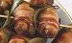
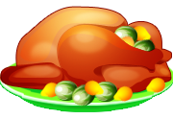
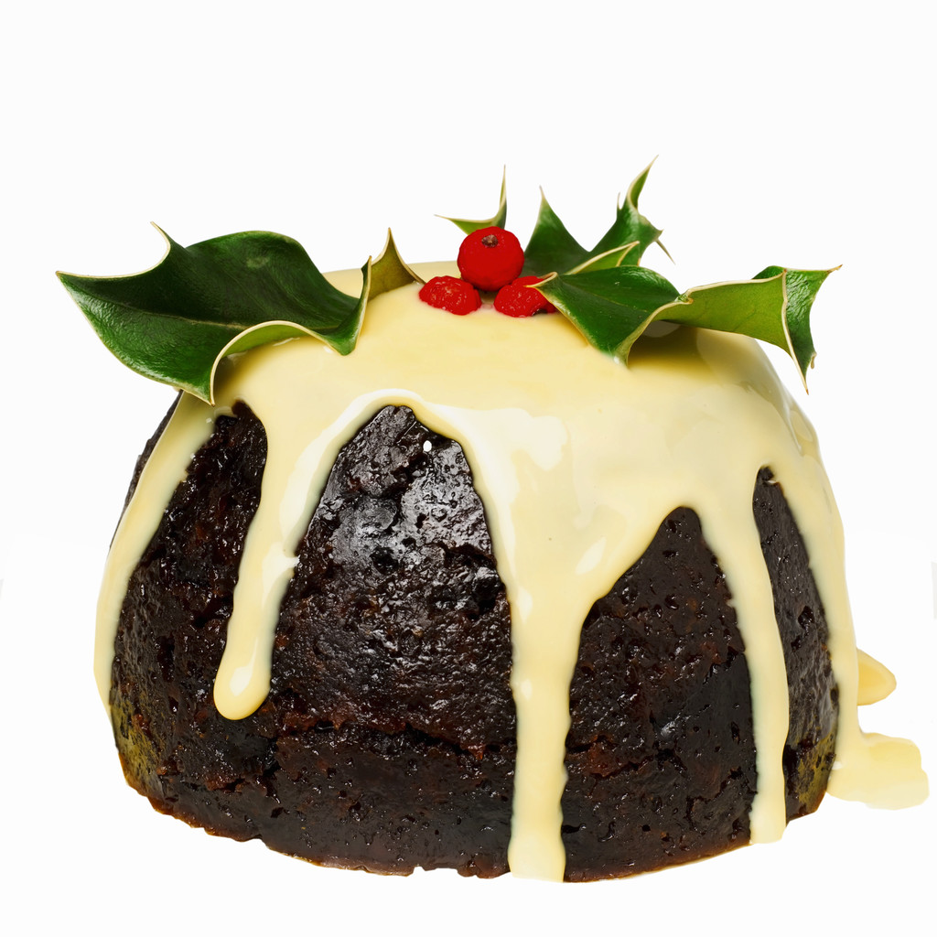

_______________________ _____________________ ______________________

_______________________ _____________________ ______________________
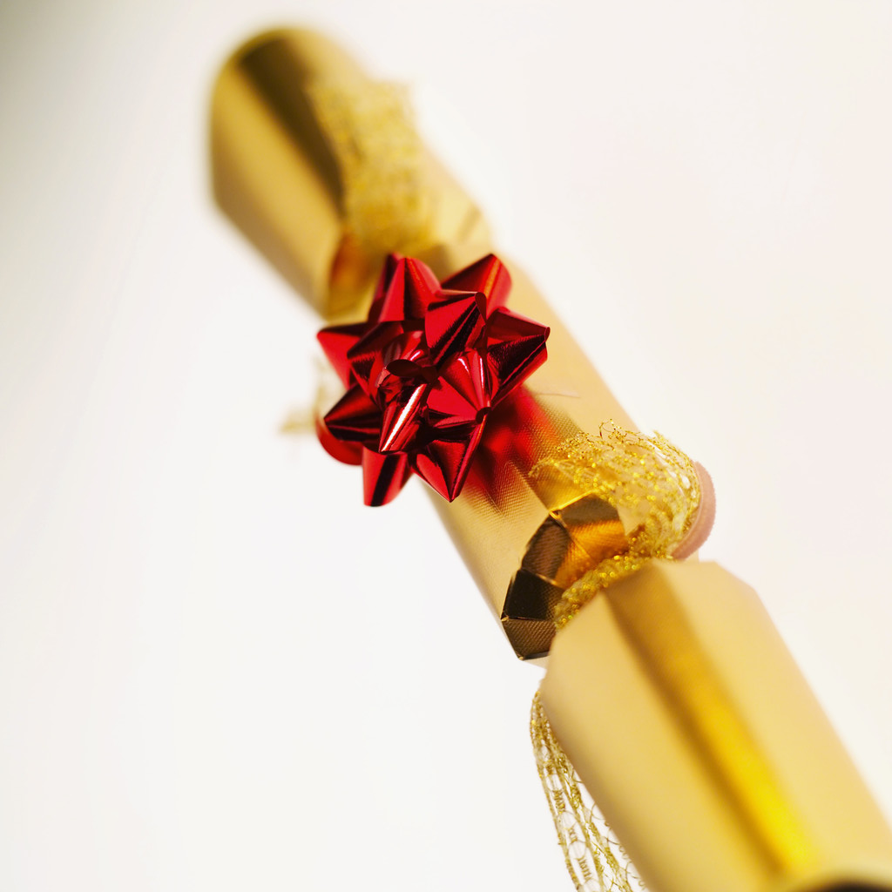
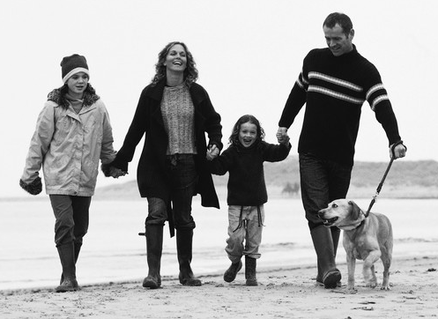

___________________ ____________________ _________________________

___________________ _____________________ _________________________

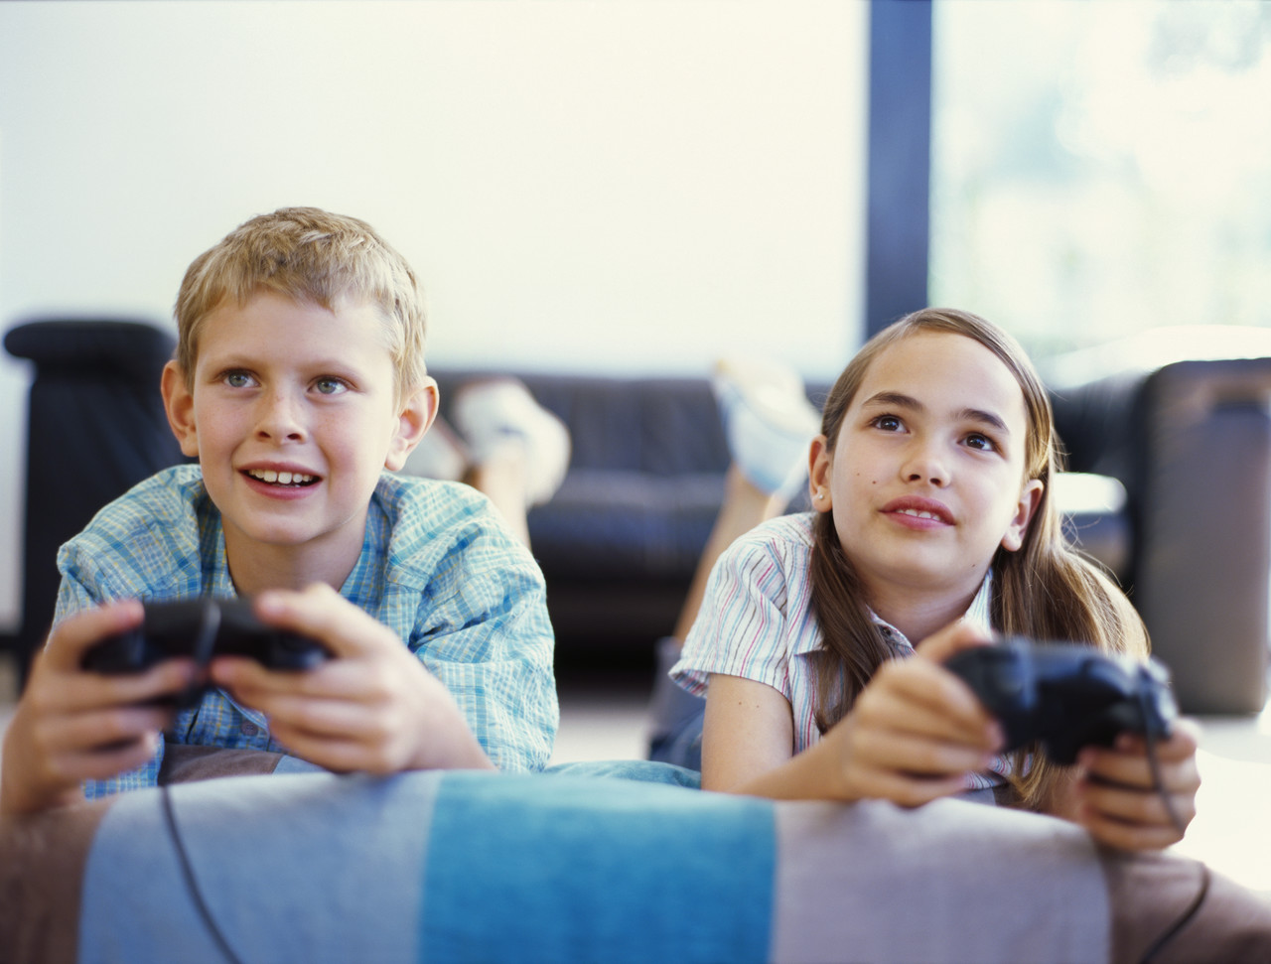

__________________ _____________________ ______________________

__________________ _____________________ ______________________

Christmas pudding, Family games, Sausages in bacon, Festive Crackers, Long lie ins, Family walks, Christmas tree, Roast Turkey, Friends to play

Favourite thing I did was … ____________________________________________________________________________________________________________________________________________________________

