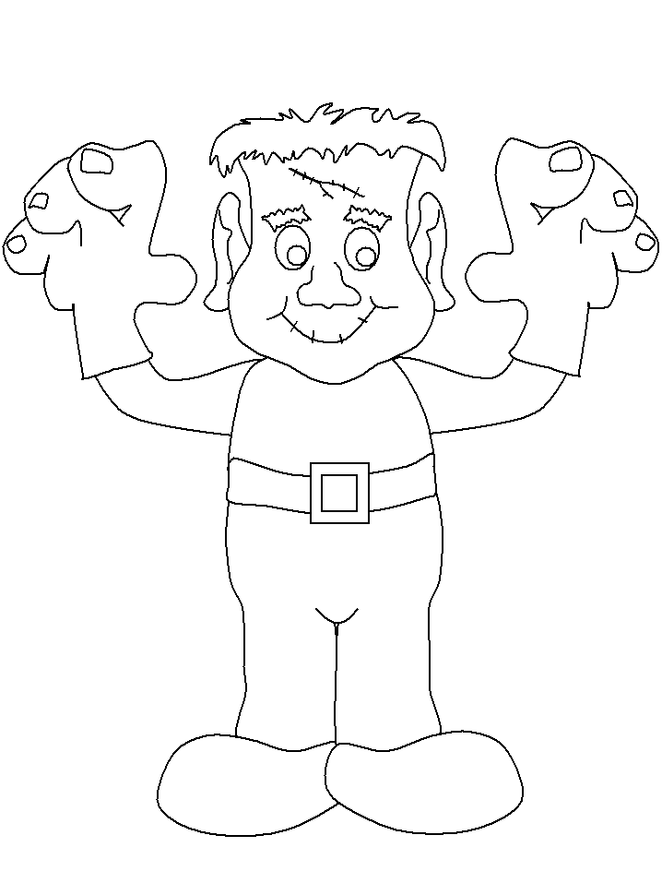
Happy Halloween
3+2
4+1
5+0
2+2
3+1
4+0
1+0
1+1
1+1+1
2+1
1+2
1 | brown
2 | orange
3 | green
4 | purple
5 | black

Happy Halloween
6-1
4+1
8-3
2+2
9-5
6-2
6-3
2+0
6-5
2-1
1+0

1 | green
2 | orange
3 | brown
4 | purple
5 | black

5 | brown
6 | orange
7 | green
8 | purple
9 | black
10-1
4+5
7+2
6+2
3+5
12-4
1+4
9-3
9-3+1
8-1
5+2

