 | Name (supplier): | Function: | Who would use it?
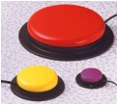 | Switches (Inclusive Technology, QED) | Mimics a keyboard keystroke or mouse click. | Users who have severe physical impairments and who cannot use a keyboard, mouse and/or their voice.
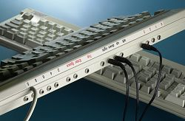 | Switch interfaces (Inclusive Technology, QED) | Used as an interface to connect a switch to the computer. | Users who have severe physical impairments and who cannot use a keyboard, mouse and/or their voice.
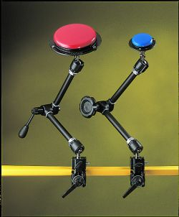 | Switch mountings (Inclusive Technology, QED) | Used to mount a switch (sometimes in conjunction with a mounting plate). | Users who have severe physical impairments and who cannot use a keyboard, mouse and/or their voice.
 | Switch accessible software (Inclusive Technology, QED) | Software which is accessible via a switch. | Users who have severe physical impairments and who cannot use a keyboard, mouse and/or their voice.  Users with learning difficulties who may prefer a small number of choices offered one at a time.

- Suppliers

Name: | Address: | Telephone: | Website:
Crick Software Ltd | Crick House, Boarden Close, Moulton Park,  Northampton NN3 6LF | 01604 671691 | www.cricksoft.com
Inclusive Technology Ltd | Riverside Court, Huddersfield Road, Delph, Oldham OL3 5FZ | 01457 819790 | www.inclusive.co.uk
Maxess Products Ltd | The Chinestone, Dancers Hill, Charlbury, Oxfordshire OX7 3RZ | 01608 811909 | www.maxessproducts.co.uk
Possum Controls Ltd | 8 Farmbrough Close, Stocklake Park Industrial Estate, Aylesbury, Buckinghamshire HP20 1DQ | 01296 461000 | www.possum.co.uk
Quality Enabling Devices Ltd | Unit D16, Heritage Business Park, Heritage Way, Gosport, Hampshire PO12 4BG | 023 92580600 | www.qedltd.com

- Websites

CALL Centre, University of Edinburgh | www.callcentrescotland.org.uk
Empowering Technologies | www.emptech.info
Inclusive Technology Ltd (Articles on Special Needs and IT section) | www.inclusive.co.uk/infosite/index.shtml
New Opportunities Fund (ICT Training) | www.inclusive.net

- Other

AbilityNet | AbilityNet Northwest, c/o AbilityNet Central England, PO Box 94, Warwick, Warwickshire CV34 5WS | 0800 269545 (if calling from home) or 01926 312847 (if calling from work) | www.abilitynet.co.uk
ACE Centre North | Units 11 & 12, Gatehead Business Park, Delph, Saddleworth OL3 5DE | 01457 829444 | www.ace-north.org.uk

