 | Name (supplier): | Function: | Who would use it?
1. Motivation (examples)
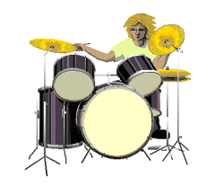 | Disco (Inclusive Technology) | Cause and effect software, via animations and images. | Users who require a visual stimulus.
 | SwitchIt! Patterns (Inclusive Technology) | Cause and effect software, via animated patterns. | Users who require a visual stimulus.
2. Memory and Cognition
(examples)
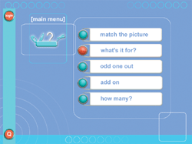 | ColorCards Interactive - Everyday Objects (Inclusive Technology) | A series of activities relating to a random selection of photographs. | Users who need to recognise the function and classification of everyday objects.
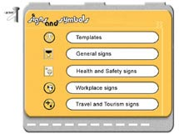 | Signs and Symbols (SEMERC) | A series of activities relating to real life sign and symbol recognition. | Users who need to recognise common real life signs and symbols.

3. Lifeskills (examples)
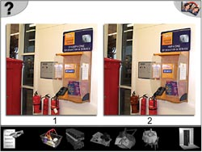 | Out and About 1 - The Living Community (Inclusive Technology) | A series of lifeskill activities including shopping, travel, banking and leisure. | Users who need to learn lifeskills such as shopping, travel, banking and leisure.
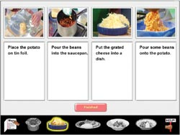 | Out and About 2 - Around The Home (Inclusive Technology) | A series of lifeskill activities including cooking, shopping, use-by dates and information gathering. | Users who need to learn lifeskills such as cooking, shopping, use-by dates and information gathering.
4. Literacy (examples)
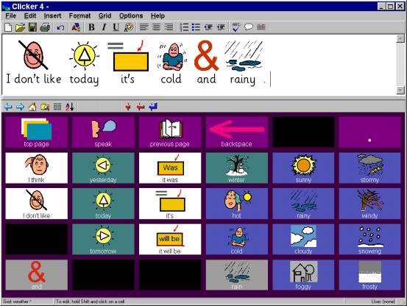 | Clicker (Inclusive Technology) | Combines a talking word processor (Clicker Writer) with grids (Clicker Grids).  Uses PCS symbols.  Switch accessible. | Users who will not always rely on text for reading and writing.  Users who need large symbol vocabularies.
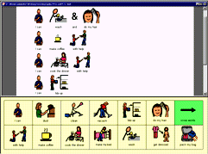 | Writing with Symbols 2000 (Inclusive Technology) | Combines a talking word processor with grids.  Uses PCS and Rebus symbols.  Switch accessible. | Users who will not always rely on text for reading and writing.  Users who need large symbol vocabularies.

 | Name (supplier): | Function: | Who would use it?
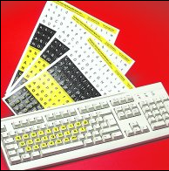 | Alphabet keyboard stickers (Inclusive Technology) | High-contrast adhesive keyboard stickers - lowercase and uppercase sets available. | Users who require the alphabet keys to be more visible.
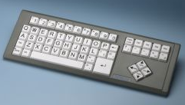 | Simplified keyboard (Inclusive Technology, Keytools) | Uncluttered layout removes unnecessary keys - lowercase and uppercase versions available. | Users who require only the essential keys necessary for writing.
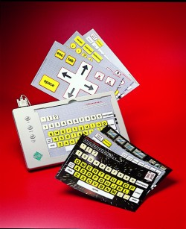 | Overlay keyboard (Inclusive Technology) | A touch sensitive surface on which overlays are placed - overlays can be tailored to suit the user. | Users who require a specific layout (overlay) to suit their particular needs.

- Suppliers

Name: | Address: | Telephone: | Website:
Crick Software Ltd | Crick House, Boarden Close, Moulton Park,  Northampton NN3 6LF | 01604 671691 | www.cricksoft.com
Inclusive Technology Ltd | Riverside Court, Huddersfield Road, Delph, Oldham OL3 5FZ | 01457 819790 | www.inclusive.co.uk
Keytools Ltd | PO Box 700, Southampton SO17 1LQ | 023 80584314 | www.keytools.com
Learning and Teaching Scotland | The Optima, 58 Robertson Street, Glasgow G2 8DU | 08700 100 297 | www.ltscotland.org.uk
SEMERC | Granada Learning, The Chiswick Centre, 414 Chiswick High Road,  London W4 5TF | 020 8996 3333 | www.semerc.com
Widgit Software Ltd | 124 Cambridge Science Park, Milton Rd, Cambridge  CB4 0ZS | 01223 425 558 | www.widgit.com

- Websites

CALL Centre, University of Edinburgh | www.callcentrescotland.org.uk
Empowering Technologies | www.emptech.info
Inclusive Technology Ltd (Articles on Special Needs and IT section) | www.inclusive.co.uk/infosite/index.shtml
New Opportunities Fund (ICT Training) | www.inclusive.net
Priory Woods School | www.priorywoods.middlesbrough.sch.uk
SEN Teacher Resources | www.senteacher.org
SymbolWorld | www.symbolworld.org

- Other

AbilityNet | AbilityNet Northwest, c/o AbilityNet Central England, PO Box 94, Warwick, Warwickshire CV34 5WS | 0800 269545 (if calling from home) or 01926 312847 (if calling from work) | www.abilitynet.co.uk
ACE Centre North | Units 11 & 12, Gatehead Business Park, Delph, Saddleworth OL3 5DE | 01457 829444 | www.ace-north.org.uk

