 | Name (supplier): | Function:
1. Customised Windows
(example)
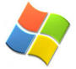 | Display Properties, Microsoft Windows (Microsoft) | Changes the desktop, short-cut icons, menu bars and scroll bars.
2. Customised mouse pointers and toolbars
(examples)
 | Mouse properties, Microsoft Windows (Microsoft)  Toolbars, Microsoft Office (Microsoft) | Changes the size, colour and/or shape of mouse pointers and the size of toolbars.
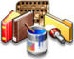 | Microangelo (Impact Software) | Design pointers and icons.
3. Screen magnification (examples)
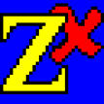 | ZoomText Xtra Level 1 (Sight and Sound Technology) | Enlarges the image on the computer screen. The level and type of magnification can be customised. (ZoomText Xtra Level 2 has magnification, plus supportive synthetic speech).
 | Lunar (Dolphin Computer Access) | Enlarges the image on the computer screen. The level and type of magnification can be customised. (Lunar Plus has magnification, plus supportive synthetic speech).

4. Screen reading (examples)
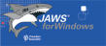 | JAWS (Sight and Sound Technology) | Converts what is happening on the computer screen into synthesised speech.
 | Hal (Dolphin Computer Access) | Converts what is happening on the computer screen into synthesised speech.
5. Optical Character Recognition
(example)
 | Kurzweil 1000 (Sight and Sound Technology) | Converts the printed word into synthesised speech, via a scanner.
6. Braille translation (example)
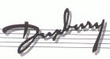 | Duxbury Braille Translator (Sight and Sound Technology) | Converts the printed word into Braille, which can then be embossed via a Braille embosser.
7. Touch typing
(example)
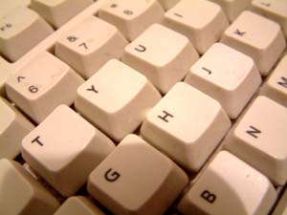 | Touch-Typing Tutor (Azabat) | Consists of 7 lessons (letter drills) and 7 exercises (word drills). Self-voiced and runs from the CD-ROM.

8. Keyboard shortcuts

(example)
Ctrl+S  Alt+F4  F7 | Microsoft Windows, Microsoft Office, Microsoft Internet Explorer | A combination of keys are used for operations commonly done using the mouse.

* Choice of appropriate software will depend on the users level of functional vision.

 | Name (supplier): | Function:
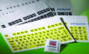 | Full keyboard stickers (Inclusive Technology) | High-contrast, enlarged print adhesive keyboard stickers - white on black, black on white and black on yellow sets available.
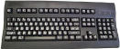 | Large print keyboard (Inclusive Technology) | High-contrast, enlarged QWERTY keyboards - white on black, black on white and black on ivory versions available.
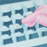 | Locator dots (RNIB) | Help locate ‘home’ keys, i.e. F and J, on the keyboard.
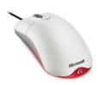 | Wheel mouse (Misco) | Moves mouse pointer, plus middle wheel button is used to scroll up and down.
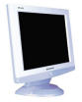 | Large screen monitor (Misco) | Produces a larger-than-normal image.
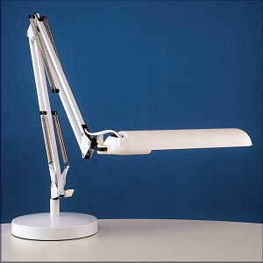 | Adjustable task lamp (Daylight Company) | Lamp, using fluorescent bulb, shines directly onto the paper and can be adjusted to suit.

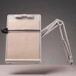 | Copyholder (Misco) | Holds printed material in near vertical position for easier reading and can adjusted to suit.
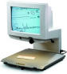 | Close Circuit Television system (CCTV)/Video Magnifier (Sight and Sound Technology) | Printed materials and objects are placed under a camera and the magnified image is displayed onto a screen.
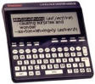 | Franklin Language Master Special Edition (RNIB) | Portable electronic spellchecker, dictionary and thesaurus, plus speech.
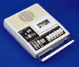 | Modified cassette recorder (RNIB) | To record a lecture, own thoughts, ideas, notes etc.
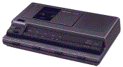 | Desktop compact cassette dictation system | To allow audio cassette playback with the aid of a foot pedal.
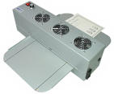 | Fuser (Zychem) | To produce tactile materials, e.g. diagrams, by using heat and special swell paper.

Electronic reading aids
(examples)
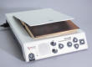 | Standalone Reading Aid | A unit which integrates a scanner, Optical Character Recognition (OCR) software and speech software. The printed document is scanned and read by the same machine.
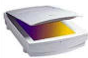 | Scanner (Misco) | A device used in conjunction with Optical Character Recognition (OCR) software. The printed document is scanned and converted into electronic text, which can then be displayed on screen as recognisable text.
Braille technology (examples)
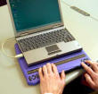 | Braille Display (Sight and Sound Technology) | An electronic tactile device which is placed under the computer keyboard. A line of cells, that move up and down to represent a line of text on the computer screen, enables the user to read the contents of the computer screen in Braille.
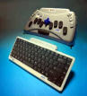 | Electronic Notetaker (Sight and Sound Technology) | A portable computer with a Braille or QWERTY keyboard and synthetic speech. Some models have an integrated Braille display.
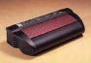 | Braille embosser (Sight and Sound Technology) | Embosses Braille output from a computer by punching dots onto paper. It connects to a computer in the same way as a text printer.
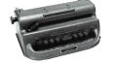 | Perkins Brailler (RNIB) | To manually emboss Grade 1 or 2 Braille.

* Choice of appropriate hardware will depend on the users level of functional vision.
- Suppliers

Name: | Address: | Telephone: | Website:
Azabat software | - | 07740 777 364 | www.azabat.co.uk
The Daylight Company | 89-91 Scrubs Lane, London NW10 6QU | 020 8964 1200 | www.daylightcompany.co.uk
Dolphin Computer Access Ltd | Technology House, Blackpole Estate West, Worcester  WR3 8TJ | 01905 754 577 | www.yourdolphin.com
Impact Software | - | - | www.microangelo.us
Inclusive Technology Ltd | Riverside Court, Huddersfield Road, Delph, Oldham OL3 5FZ | 01457 819790 | www.inclusive.co.uk
Microsoft | Microsoft Limited, Microsoft Campus, Thames Valley Park, Reading RG6 1WG | 0870 6010100 | www.microsoft.com/enable
Misco | Darby Close, Park Farm Industrial Estate, Wellingborough,  Northants NN8 6GS | 0870 7256990 | www.misco.co.uk
RNIB (Royal National Institute of the Blind) - main address | 105 Judd Street, London WC1H 9NE | 0845 766 9999 | www.rnib.org.uk
Sight and Sound Technology | Qantel House, Anglia Way, Moulton Park, Northampton NN3 6JA | 0845 634 7979 | www.sightandsound.co.uk
Zychem Ltd | Valley Court, Sanderson Way, Middlewich, Cheshire CW10 0GF | 01606 738739 | www.zychem-ltd.co.uk

- Charities

AbilityNet | AbilityNet Northwest, c/o AbilityNet Central England, PO Box 94, Warwick, Warwickshire CV34 5WS | 0800 269545 (if calling from home) or 01926 312847 (if calling from work) | www.abilitynet.co.uk
The British Computer Association of the Blind | C/O RNIB, 58-72 John Bright Street, Birmingham B1 1BN | 0845 430 8627 | www.bcab.org.uk
RNIB Technology | PO Box 173, Peterborough  PE2 6WS | 0845 900 0015 | www.rnib.org.uk/technology

- Websites

BBC BETSIE - a filter program used by the BBC to create an automatic text-only version of its website. | www.bbc.co.uk/education/betsie
Empowering Technologies | www.emptech.info

- Book

‘Accessing technology: Using technology to support the learning and employment opportunities for visually impaired users’ (2001). Publisher: Royal National Institute of the Blind. ISBN 1858785170

