Black History Month Activities
A spotlight on Black and African history
Written by Fidelia Nimmons
Does lack of archaeological or written language evidence mean a lack of Black People history?
Extracts from President Barack Obama’s speech in Ghana 11 July 2009
‘So I do not see the countries and peoples of Africa as a world apart; I see Africa as a fundamental part of our interconnected world ‘
‘Here in Ghana, you show us a face of Africa that is too often overlooked by a world that sees only tragedy or a need for charity.’
‘Ghana's history is rich,’
Read the full speech on : http://www.america.gov/st/texttrans-english/2009/July/20090711110050abretnuh0.1079783.html#ixzz0P5V3JlLD
A case study of The Great Kingdom of Benin
Read a short history of this great kingdom which continues till today on the following link:
http://wysinger.homestead.com/benin.html
For more detailed information, view the Ancient Kingdom of Benin lesson notes by Fidelia Nimmons on the following link:
http://www.primaryresources.co.uk/history/history.htm
(To view this, you will need to download the SMART software from:
http://www2.smarttech.com/st/en-US/Support/Downloads/Notebook+IV/NIVv95Win.htm)
View the British Museum collection on this web link:
http://www.britishmuseum.org/explore/highlights/highlight_objects/aoa/b/brass_plaque_showing_the_oba_o.aspx
View the royal court ceremonial activities on:
http://www.youtube.com/watch?v=okn1nwnCQBQ&feature=related
http://www.youtube.com/watch?v=42wh42tH168&feature=related
Children will learn how to:
- carry out an historical enquiry
- identify a variety of sources of information using primary and secondary sources- oral history, artefacts, historical accounts from the past , photographs
- distinguish between relevant and irrelevant information and events placing ideas in order, chronological and other
- differentiate fact from opinion
- Increase their knowledge of Black and African history.
It has often in the past, been claimed that Black People have no history and that any black history begins from the transatlantic slave trade. However, black history date back as far as any other peoples’ history as the African people have preserved their history perfectly well through their oral tradition.
Black and African history is their way of life; and this remains largely unchanged by the indigenous ethnic groups. This enquiry, focuses solely on the Great Kingdom of Benin but historical enquiries can be carried out on any other African kingdom or tribe e.g. the Zulu, Ashanti, Bantu, Maasai, Fulanis, and Pygmies etc.
Sources of historical evidence:
There are two sources of historical evidence, primary and secondary.
Primary evidence is a firsthand account of an event and includes diaries, journals, letters, speeches, news stories, photographs, and pieces of art:
Secondary evidence sources are works that are based on analysis of primary sources, such as textbooks, biographies, nonfiction books about history and monographs; they often also include quotations or illustrations from primary sources.
Oral traditions and oral histories are as old as humanity and provide another way to learn about the past from people with firsthand knowledge of historical events. Most African history is passed down this way as tribal and community leaders and other witnesses pass information from generation to generation using stories, anecdotes, songs and their daily practice of their customs.
This material meets the two historical sources rules:
Time and place rule: Events referred to are documented as they happen and the author is a direct participant at the events and if not; interviewed those involved immediately afterwards for example interment of a late Edo Chief procedures.
The bias rule: all of the evidence have been cross checked with other sources and related evidence e.g. the burial ceremony, celebrations, rituals and ceremonies by the Edo Royal Court. Engravings by the Dutch artist Dapper of 1668 is compared with modern day practices of Edo Royal processions. Edo’s own records of their history through their works of art is also analysed.
Vocabulary
Historical source
Primary source
Secondary source
Oral history
Written history
Evidence
Genealogy
Beliefs
Customs Extended family
Myths
Traditions Nuclear family
King
Kingdom
Artwork
Mosaic
Frescoes
Necropolis
Fallow
Immortality
Monastery
Patron Saint
Venerate
Shroud / Mat shroud
Casket
Pupils’ activities:
Considering evidence
Royal court ceremonies
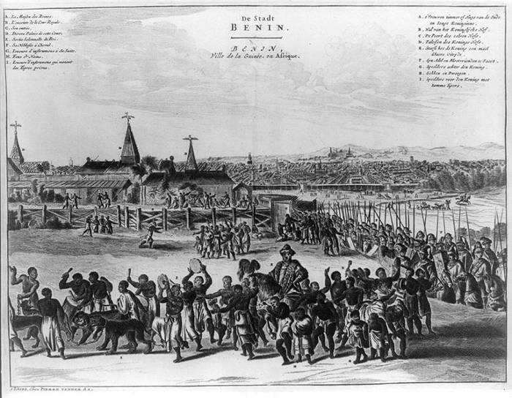 Oba of Benin, Igue procession, Dapper 1668. Notice the singers and dancers surrounding him, and the long procession of people.
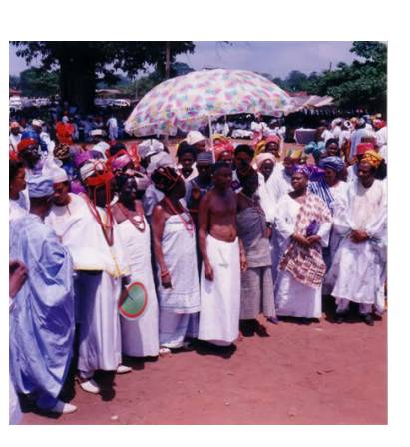 Chief Ebenzer of Igueben conferment walkabout 1996, notice the procession of people, musicians in the background. Compare this picture to the one above

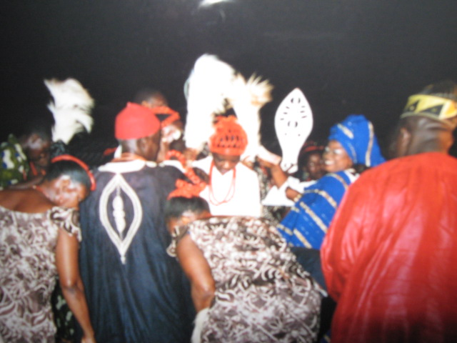FN in an Eben dance procession at Chief Ebenezer’s burial ceremony 2007
Questions on the pictures
What can you see happening in the pictures?
What are the same about all three pictures?
What are the differences between the pictures?
What do these pictures tell us about the Edo way of life?
Watch the video on youtube of Igie ErhOba on http://www.youtube.com/watch?v=42wh42tH168&feature=related
Questions:
What has changed since 1668 to present day?
What has remained the same?
What do we learn about Edo history from the pictures and videos?
Burial ceremonies
Just like the Ancient Egyptians, Greeks, and Romans, the Ancient Edo people believed in the afterlife; and burial of the dead included providing them with what they would need to carry on their lives in the afterlife, including burying kings with a host of servants and maids together with items for daily survival e.g. food.
The ancient Egyptians had a tradition that tombs where nobles were buried should resemble the houses of the living, as the tomb was the house of the dead. This tradition influenced both the Greeks and Romans burial practices. The Edo also held similar beliefs. Whilst evidence for this tradition for the other civilisations lie in the archaeological finds and well preserved structures they left behind, the Edo continue to retain aspects of this tradition in burying their nobles in houses where they can remain in the comfort of their own homes and where their burial place can be easy identified; so their stories are not forgotten.
Look at these pictures:
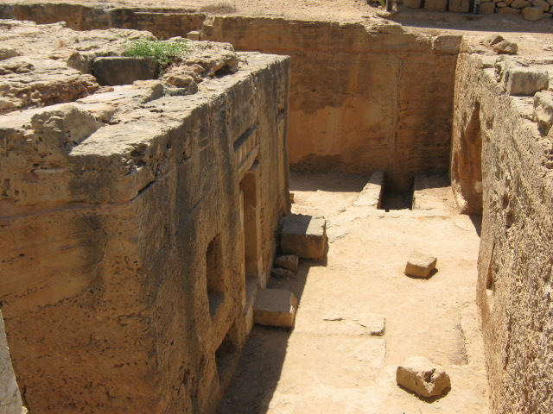 Tombs of the kings, excavated in 1977, in Pafos, Cyprus, caved into solid rocks, they derived from Egyptian tradition and feature Greek architecture. Used for burying nobles, they date back to 3000BC to 3000AD and were plastered and covered with frescoes. The nobles were buried with personal items and belongings
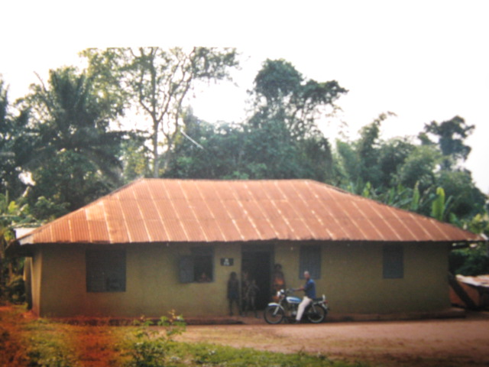Burial place of Prince Omhelimhen Okunsebor 2006. This was his home, where he was buried in his bedroom. The house is part of a larger compound with modern houses for his family. Notice the people standing in front of the house, they keep his room locked and clean. As per tradition, this house as much as possible must be preserved for eternity and as the burial place of the prince, must be revered and respected. The Prince is never to be disturbed.
In the absence of solid rocks to chisel into in the rainforests, the Edo use this method to protect their dead for eternity.
Questions:
What are the similarities between the two pictures?
What are the differences?
Discuss the similarities between the burial traditions
Edo still bury their nobles in their own homes, what do you think has made possible for the them to carry on with this tradition?
Which other aspects of ancient burial traditions do you think the Edo still retain? Why do you think so? Hint: lots of Edo people are Christians.

Artwork
Throughout history all cultures have recorded their own story through their art work.
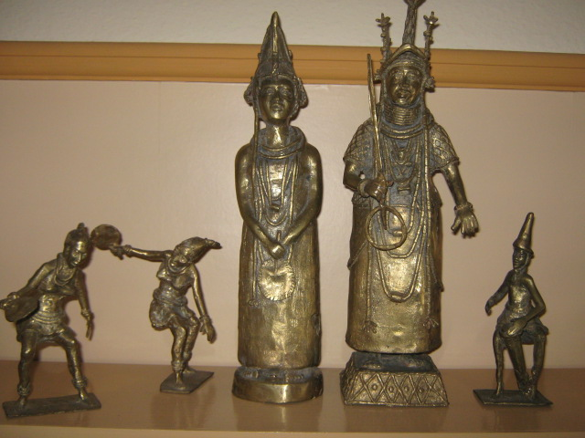 Edo brass work showing the Oba and the Queen Mother with dancers and drummers. We can tell how the Oba and Queens dressed, how the dancers and drummers dressed and they performed.
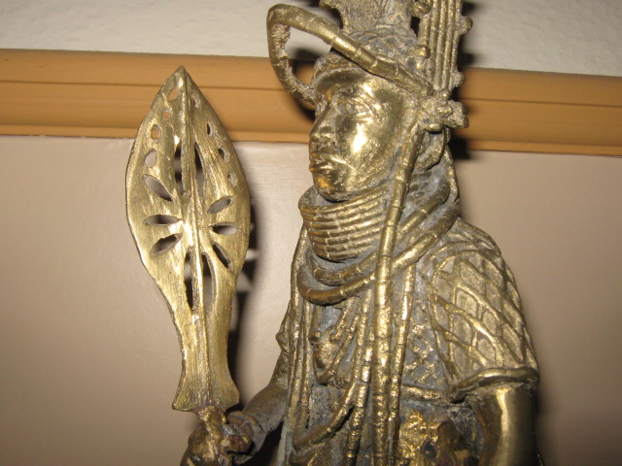In This brass work, The Oba wears beaded crown and his full beaded royal regalia, carrying the Eben, his staff of authority.
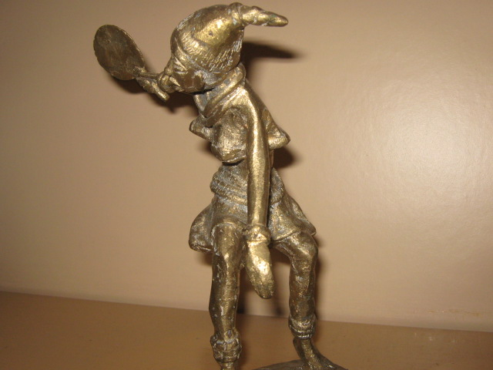From the brass work, we know how the dancers dressed. Though naked, the dancer is fully adorned with beads on the ankles, wrist, waist, neck, and head. She holds a hand fan for cooling herself
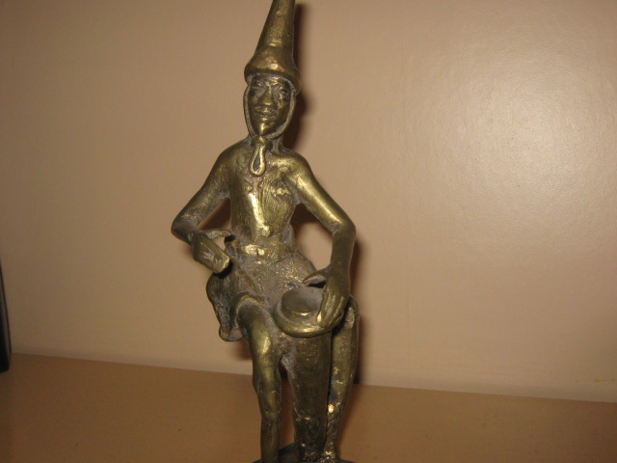This shows how the drummer balances his drum between his knees to get the right beat
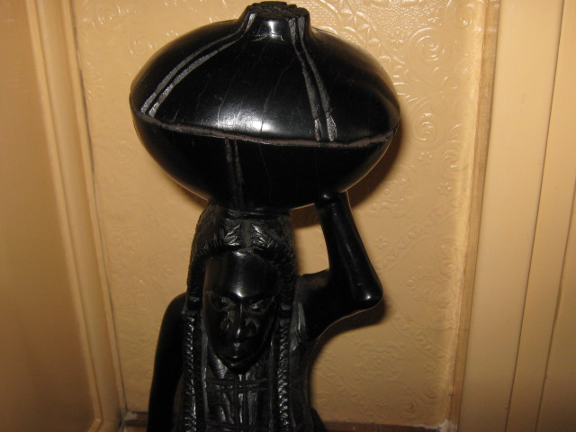 Edo wood carving, showing a woman carrying gourd on her head; probably containing farm crops. We can tell female hair styles, means of transporting objects and equipment used.
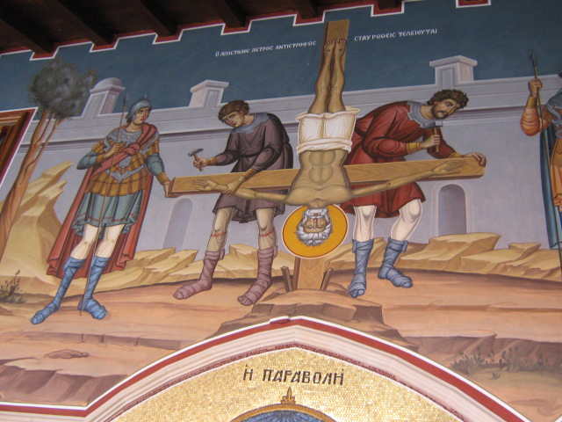 Holy Kykkos Monastery Cyprus frescoes; showing the crucifixion of St Paul, We can see how he was hung. The Christians used mosaic and frescoes to depict bible stories and significant events in their history.
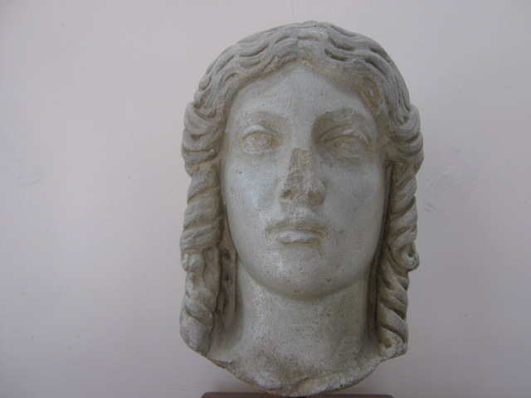 Statue of the Goddess Aphrodite, the Greeks used marble statues to record their religious beliefs and significant events in their history e.g. The first Olympic games.
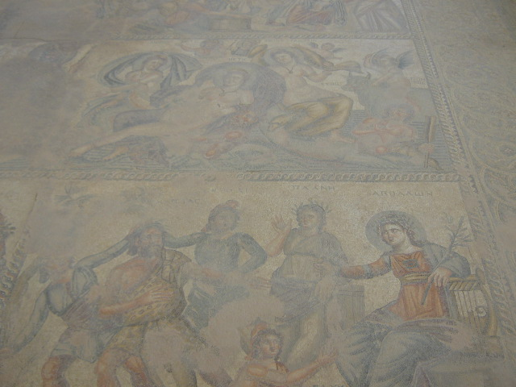Dating back to 3rd AD; Roman mosaic floor in The House of Aion, Kato Pafos; showing the myth Apollo and Marysos. Roman houses used spectacular mosaics to depict scenes from ancient Greek mythologies and to show their wealth..
Questions
Why do you think cultures have used artwork to record their history over time?
What methods are used to record cultural histories today?
Genealogy:
With written records, family trees help us record our relatives and ancestors lineage and to trace our ancestry. Edo do this effectively by naming their new born babies after significant relatives of the past, They are able to pass on stories of significant events and achievements, this way; they are also able to date events accurately using this method. Through this children naming system, stories of events up to the fourth and fifth generation and beyond are accurately retold and passed on. This ensures they remain part of their history
Here is an Edo family simple genealogy:
Baby boy born in July 2009 named: Omeike
He is first son of Ozin
Who is son of Odigie
Who is son of Aigbogun
Who is son of Omeike (DOB: late 1800s and a famous blacksmith)
Look at this picture
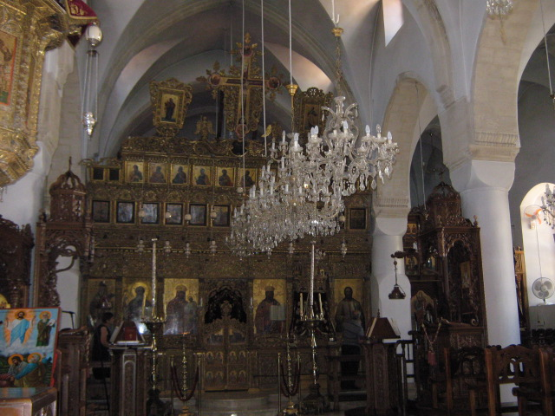 The Christians have used icons to record significant persons in their church’s history in chronological order. This serves the same purpose as a family tree or genealogy in helping trace significant people in their history.

Questions
What are the similarities between both systems?
What are the differences between both systems?
What does your family tree look like?
Food production:
Land fallow and crop rotation
Look at this picture
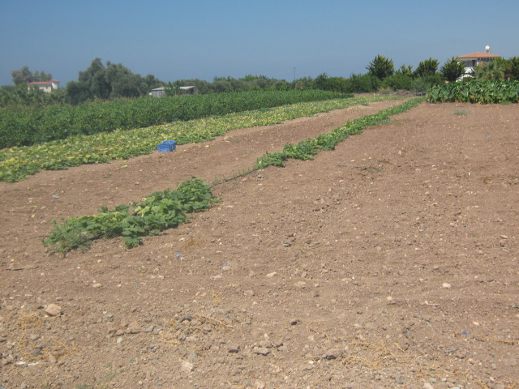 A piece of land is left fallow and will be farmed next year. This method along with crop rotation, improve soil fertility naturally. We know how Edo cultivated their lands successfully from some of their current practice.
Questions:
What can you see?
Who do think owns the land?
What can you see in the background?
Why has the land been left fallow?
What methods are used today to improve soil fertility and crop yield?

Extended family system:
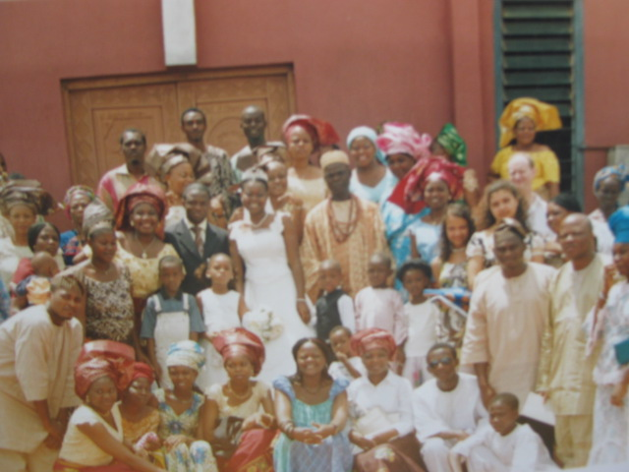
Questions:
What can you see in this photograph?
Who are these people?
What are they doing?
Why are there so many members in one family?
What are the advantages of belonging to an extended family? What are the disadvantages?
With the advancement of face book, webcams, emails, twitters and the internet, what challenges do you think these family members face when communicating with each other? With the whole group? With their friends on the World Wide Web?
Would you like to belong to an extended family like this? Why?
Wedding Ceremonies
No wedding is considered binding in Edo culture without the native traditional wedding; which provide more opportunities to sing, dance and celebrate. A dowry price must be negotiated and paid by the groom’s family to compensate the bride’s family for the loss of her labour and earnings powers.

Look at these pictures:
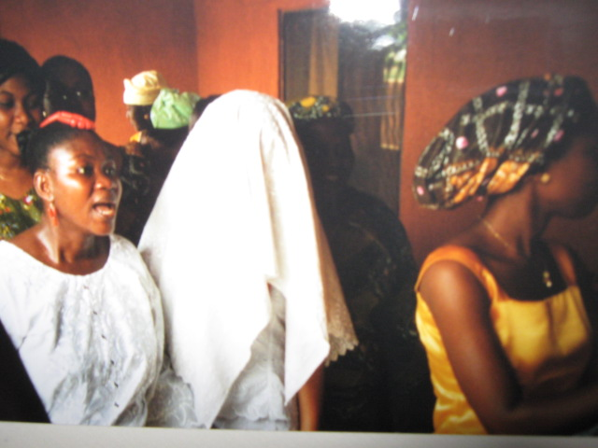 Identity parade; which is your bride? The groom must identify his bride from a number of covered up maidens or be sent packing as not truly knowing his bride to be.
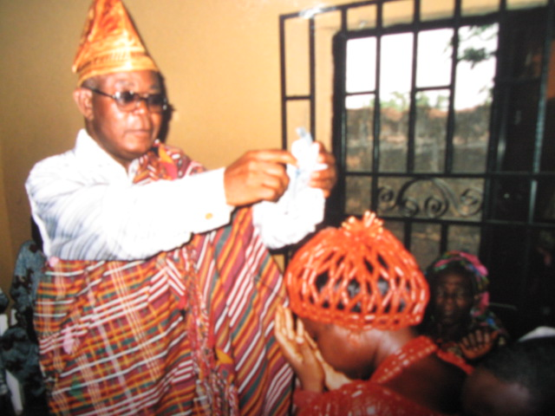 The bride’s father has to formally bless her before giving her away.
Questions:
Look at the first picture; what jobs do you think the girls in the picture do? How do you know?
Look at the second picture. What job do you think the bride’s father does? How do you know?
The bride is a lawyer, how much dowry do you think the groom was levied this time?
(answer to question 1 above in order- hospital matron, trainee doctor, pharmacist; question 2 – a barrister)

Dress and fashion
Look at this picture
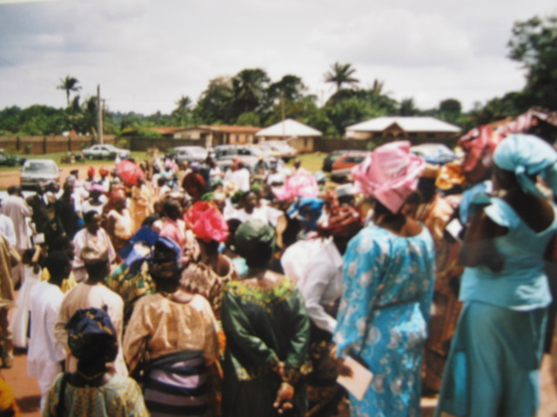
Questions:
Explain what is happening in this photograph.
Who are these people?
Where are they going or coming from? (Answer: church service)
Can you identify their fashion style?
Imagine a conversation between two of the people, what will they say to each other? Draw speech bubbles to show this.
Freeze frame part of the photograph and dramatise what is happening, what happened before now? What happened after wards?
You are one of the people in the picture; make an entry on your twitter web page
Pick one of the dresses that you like and made a drawing of it.

Stories and Myths
Just like other cultures, Edo tell the mythical story of how Osanobua the high King of the sky first created the world, he is still considered the utterly benevolent God and Edo refer to the universal God as Osanubua. The first kings of Benin, the Ogiso kings are said to have descended from him and they appealed to him as a last resort when all else had failed.
Read the full story on http://www.primaryresources.co.uk/history/history.htm Ancient kingdom of Benin, in the Religion section

Look at this picture
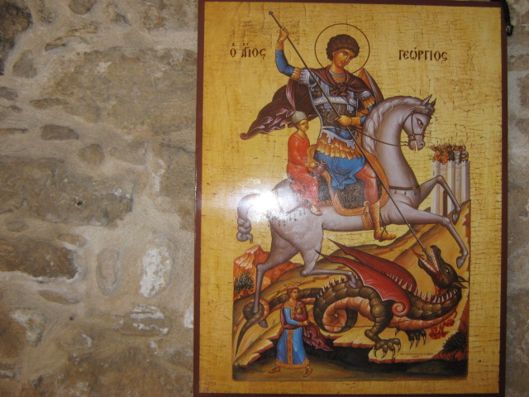 St George is the patron Saint of a lot of countries, including England, Russia and Greece. He is also patron saint of cities like Gozo, Moscow, etc and of lots of organizations e.g. Scouts, professions e.g. the military and of some disease sufferers e.g. skin disease. Even though, the story of St. George and the Dragon is a myth, he continues to be venerated across the world.
Questions
Research the story of St George and the Dragon and list similarities and differences between this story and Benin religion and their creation story.
Reflection: Black and African history is the peoples’ way of life, well preserved through generations; and which has been overlooked by Western historians in the past.
Extra: DNA tests can help some black people trace their ancestry and hence their personal history, research how this can be done.

Other activities
Research and produce a timeline of the Kings of Benin
Watch the Igu’Oba video; make a sketch of two chiefs, one in red and one in white, find out the significance of these colours for the Edo people. http://www.youtube.com/watch?v=okn1nwnCQBQ&feature=related You may also find the primary Resources file on Ancient Kingdom of Benin useful.
Watch the Edo chiefs dancing in the video, why do you think there are no females? How do you think the females would be feeling watching only men dancing in the celebration of their cultural heritage, what makes you say that?
Research the significance of red and white colours in Edo customs on: http://www.primaryresources.co.uk/history/history.htm
It is Edo custom that the Oba never leaves the palace, except during the Igue festival as depicted in Dapper’s engraving of 1668 and shown in the Igie ErhOba video. Compare the video with the engraving; do you think Dapper’s engraving was an accurate representation of this festival? What is your evidence for this view?
Research Kingdom of Benin 15th & 16th century trade with the Europeans? Produce a guide booklet on ‘Trading with The Kingdom of Benin’
You are an Edo chief; write a blog about your dance for the king on your web page. How did you feel a day before, on the morning of the day? What do you think of the other chiefs? Does any of them get on your nerves or try to out dance you? Did the Oba say anything to you? How do you feel during your dance? How did you feel at the end of the dance?
Imagine you are a spectator at the Igu’Oba festival; send a post card home about your experiences.
As a class debate the topic ‘Not all historical evidence holds equal value’
Rank the following historical evidence in order of reliability giving your reasons.
diaries, journals, letters, speeches, news stories, photographs, and pieces of art, paintings, films, textbooks, biographies, popular songs, stock inventories, oral stories, stories and tales, museum artefacts , genealogy, interviews, customs and way of life.
Research DNA and write a report on ‘Using DNA tests to find your ancestry’
Produce your personal family tree up the fourth generation. You may find this web site useful: www.myheritage.com
If you had an Edo heritage, which customs would you observe and which would you not; and why?
Do you agree with President’s Obama’s statement above that Ghana and other African countries’ history is rich,’ Give your reasons.
Produce an illustrated booklet titled The Great Kingdom of Benin
Present the Igu’Oba dance to your school assembly.

Review of your historical enquiry
What did you learn from this enquiry?
What did you find interesting?
Did anything surprise you? What and Why?
Did you find any part of the work challenging? Which and why??
What new information did you learn about Black and African History?
What are your views on Black and African history now?
What project will you undertake during next year’s Black History Month?
What further studies are you going to carry out after completing this study?
Summarise this project in one word.

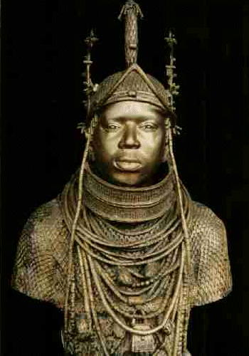 Oba of Benin in Bronze cc. Africarts

Useful web links
History at KS1&2 Unit 10
http://www.standards.dfes.gov.uk/schemes2/history/his10/?view=get
Citizenship at KS1&2 Unit 05
http://www.standards.dfes.gov.uk/schemes2/ks1-2citizenship/cit05/?view=get
http://www.america.gov/st/texttrans-english/2009/July/20090711110050abretnuh0.1079783.html
http://www.primaryresources.co.uk/history/history.htm
http://www.britishmuseum.org/explore/highlights/highlight_objects/aoa/b/brass_plaque_showing_the_oba_o.aspx
http://en.wikipedia.org/wiki/Benin_Empire

Attachments
Kings of Benin timeline
EARLY PERIOD (1170AD) | Ogiso kings
 | Oranmiyan
Early 14th century  or before | - Eweka 1  - Uwakhuahen  - Ehenmihen  - Ewedo
c. late 14th century | 5. Oguola  6. Edoni  7. Udagbedo
c. early 15th century | 8. Ohen  9. Egbeka  10. Orobiru  11. Uwaifiokun
WARRIOR KINGS | 12. Ewuare
c. mid- 15th century | 13. Ezoti  14. Olua
c. late 15th century | 15. Ozolua
to early 16th century | 16. Esigie  17. Orhoghua
Late 16th century | 18. Ehengbuda
CRISIS AND RENEWAL | 19. Ohuan  20. Ohenzae  21. Akenzae  22. Akengboi  23. Akenkpaye  24. Akengbedo  25. Ore-oghenen
c. late 17th century | 26. Ewuakpe  27. Ozuere
c. 1715 | 28 Akenzua
c. 1735 | 29. Eresoyen
c.1750 | 30. Akengbuda
c.1804 | 31. Obanosa  32. Ogbebo
c.1815 | 33. Osemwede
c. 1850 | 34. Adolo
END OF THE KINGDOM (1897) | 35. Ovoranmwen
NEW PERIOD (1914) | 36. Eweka 11
1933 | 37. Akenzua 11
1979 | 38. Erediauwa
Adapted: P. Girshick Ben-Amos The art of Benin (London, The British Museum Press, 1995)
Kingdom of Benin Location
Benin City is in Nigeria
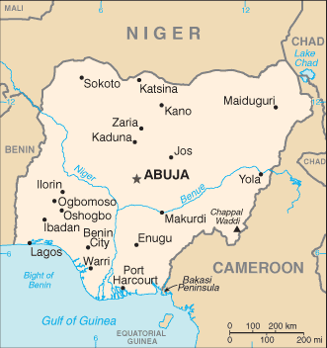
Nigeria is in West Africa
