Name____________________________ Treasure Hunt

 | Symbol | Answer |  | Working out
 | 
 | 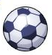
 | 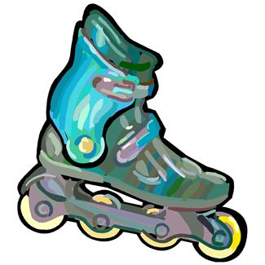
 | 
 | 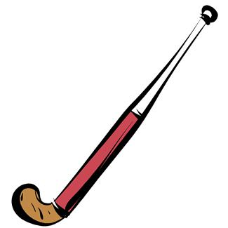
 | 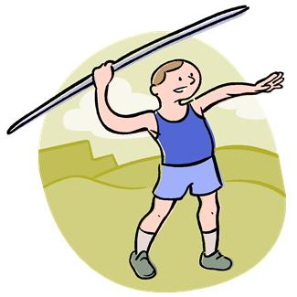
 | 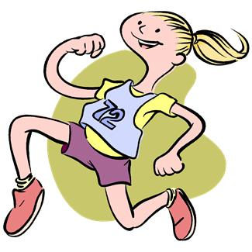
 | 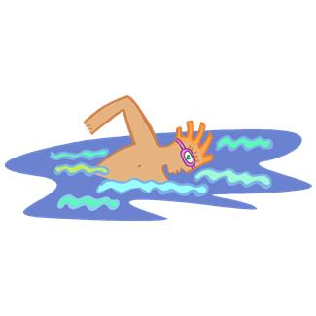
 | 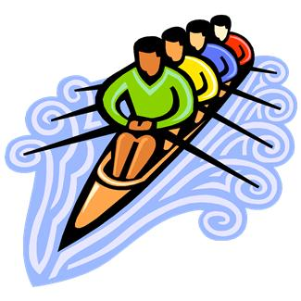
 | 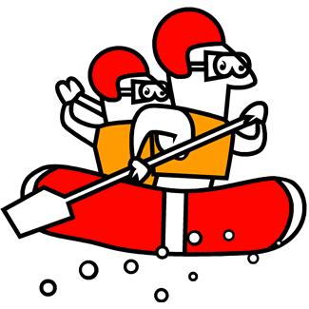
 | 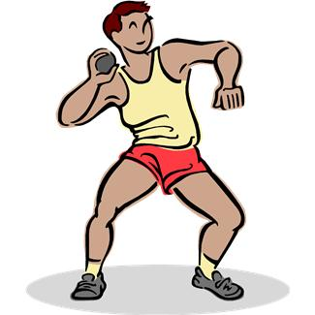
 | 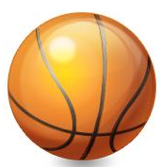
 | 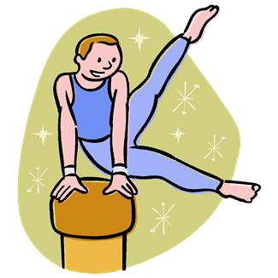
 | 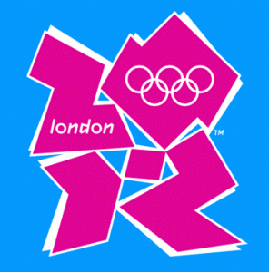
 | 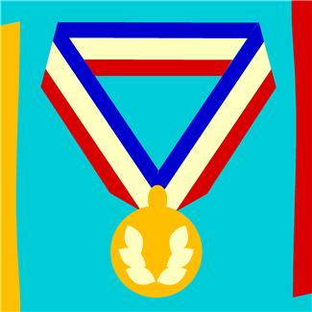
 |  |  | China won 51 gold medals at the 2008 Beijing Olympics. If they triple that number in 2012 how many gold medals will they take home?
 |  |  | In a football game there are 2 teams of 11 players. Each player needs a shirt. How many shirts are needed for 14 matches?
 |  |  | Each skate has 4 wheels. How many wheels are there on 36 pairs of skates?
 |  |  | Great Britain won 47 medals in the 2008 Beijing Olympics. If they triple that score at the London Olympics how many medals will they win?
 |  |  | Each hockey team has 11 players, 5 substitutes and 4 coaches. How many people are there in 32 teams?

Each competitor has 4 attempts at throwing the javelin. There are 58 competitors entering the competition. How many throws in total?

If there are 16 people in the final of the 800m how many metres are run altogether?
There are 9 finalists in the 200m freestyle swimming. How many metres are swum altogether in the final?
20 countries enter the rowing race, each team has 4 rowers. How many rowers are there altogether?

There are 82 athletes entering the competition. If each athlete needs a helmet, paddle, safety goggles, life vest and canoe how many pieces of equipment are needed altogether?

If a gold medal is worth 50 points and Great Britain has won 19 in the Olympics, how many points have they scored altogether?
There are spaces for 444 stickers in the London 2012 Official Sticker collection books. How many stickers will 35 people collect in total to fill their books?
There are 196 gymnasts at the Olympic Games. If each competitor performs 4 times how many events will that be?
There are 12 teams entering the Olympic Handball events. If there are 28 people per team how many people are entering altogether?
In football there are 16 men’s teams and 12 women’s teams. If each team plays 3 games how many games are played altogether?

