Trial of Mr. Jack Smith
Colonial Industrialist in A Rainforest Area

Mr Jack Smith – A Plantation Owner is indicted on the following crimes against humanity
- Destroying the rainforests by hacking and clearing large forest areas; thereby causing global warning and the resultant green house effects
- Hunting rare animals almost to extinction as a pass time hobby
- labeling indigenous people as sub- humans
- Exploiting local beliefs by claiming to be from heaven and setting up own religion in place of theirs
- Treating indigenous people no better than slaves on their own land
- Disregarding the skills and industry of indigenous people by labeling them as lazy and uncultured and without history
- introducing racial discrimination and segregation laws thereby causing untold human suffering

Duing these series of actvities the students will:
  - Learn about some aspects of Black history
  - Consider evidence from different points of views
  - Use an expert as a source of gathering information
  - select relevant information from a wide range of sources
  - engage in group discussions to arrive at a reasonable conclusion
  - raise different types of questions appropriate to the task
  - use a range of oral techniques to present persuasive arguments and engaging narratives
  - Participate in whole class debate using the conventions and language of debate, including standard English
Vocabulary:
Evidence
Oral source
Written source
Photographic evidence
Customs
Industrialist
Colonialist
Exploit
Trial
Crime
Defendant
Prosecutor
Law
Courts
Jury
Proceedings
Your Honour
Indicted
Convicted
Acquitted

Procedure:
- One week before the mock trial day, display public notices around the school informing people of the upcoming trial. Provide details of charges and location of trial e.g. in the school hall or a classroom
- Select an adult who has researched the area thoroughly and can give informed and accurate answers to questions that the students may raise on the day; this expert will be the named accused – Mr Jack Smith
- On the trial day; meet together as a group to introduce the learning intentions for the day and to consider the charges and see the evidence the prosecution will be presenting.
- Provide students with time table for the day, i.e., the time limits they have for each part of the activities
- Allocate different photographic evidence to different groups of children to discuss and raise questions on; if preferred students could select which photographs they wish to work on.
- Provide students with access to other sources of information e.g. history books, the internet or knowledgeable teachers and other adults
- Students in their groups consider each photograph in turn and raise questions they wish to ask about it. A PowerPoint handout could be used to record these.
- After the research and questions raising sessions, gather students in the ‘trial/ courtroom’.
- Arrange appropriate sitting places for students as the ‘Prosecuting team’ and put Mr Smith in the dock as the ‘defendant’
- The judge introduces the case and indictment charges and invites Mr Smith to enter a plea ‘These are the charges, how do you plead, guilty or not guilty?’
- Begin the ‘trial’. The prosecuting team states its case, presents its evidence and ask questions, to which Mr. Smith responds. Evidence includes photographic and eye witness accounts and other evidence.
- The defence team presents its case using photographic and eye witness accounts and other evidence. Questions are put to Mr Smith.
- Both sides sum up their case and urge the jury to find or acquit the defendant using emotive words.
- Whole school jury vote on which side has presented the most overwhelming evidence to support its case
- The defendant is acquitted or sentenced.
- The jury is dismissed
- The court proceeding is closed

Example of Public Notice

The Trial of Mr Jack Smith the Colonial Industrialist will take place on Monday 18th of January in the year of our Lord 2009 at The Hague School hall.

Mr Smith is charged with crimes against humanity and destructive actions against our Planet Earth

The court will begin sitting at 8.45am. You are all invited to attend as good citizens of our world

The following exhibits are presented as evidence in the case.

Exhibit 1

Extracts from a letter from Christopher Columbus to the King of Spain in the 1600s.

After raising the cross of Christ and the flag of Spain on the shores of the New World wrote to the king that the natives “have a knowledge that there is a God above and are firmly persuaded that we come from heaven.” They should be Christianized, he added and the king would receive much gold from the country.

Exhibit 2: Christianizing the natives
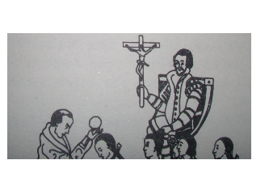
What questions would you like to ask about the extract above?
What questions would you like to ask about the photograph?

Remember to think about the quality of your question:
Which questions would be easy to answer?
Which questions would be hard to answer?
Which questions would get interesting answers?
Which questions are likely to get the facts from the defendant?
NOTE: The belief of the natives that the new comers came from heaven was used to trick them. The white men offered the natives a voyage to paradise to see their dead forefathers. They won by use of words alone.

Exhibit 3 : Pristine Rainforest before the advent of The White Man
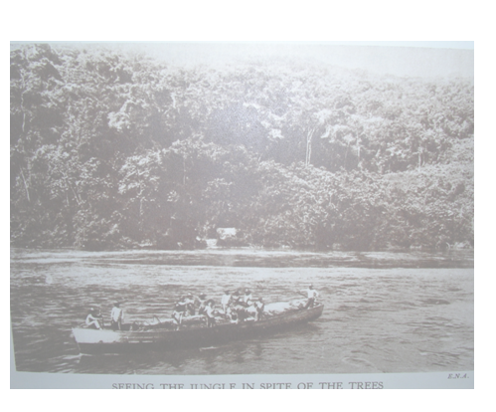

Exhibit 4: Hacking their way through the Rainforest
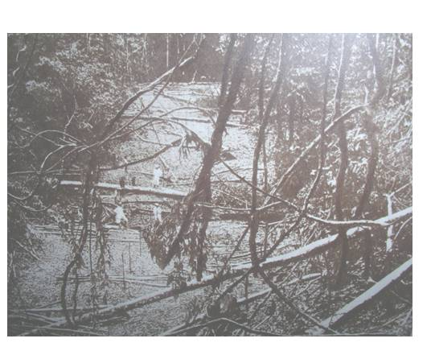
Exhibit 5: Elephant tusks used to make piano keys, umbrella handles, backs of brushes and many other items

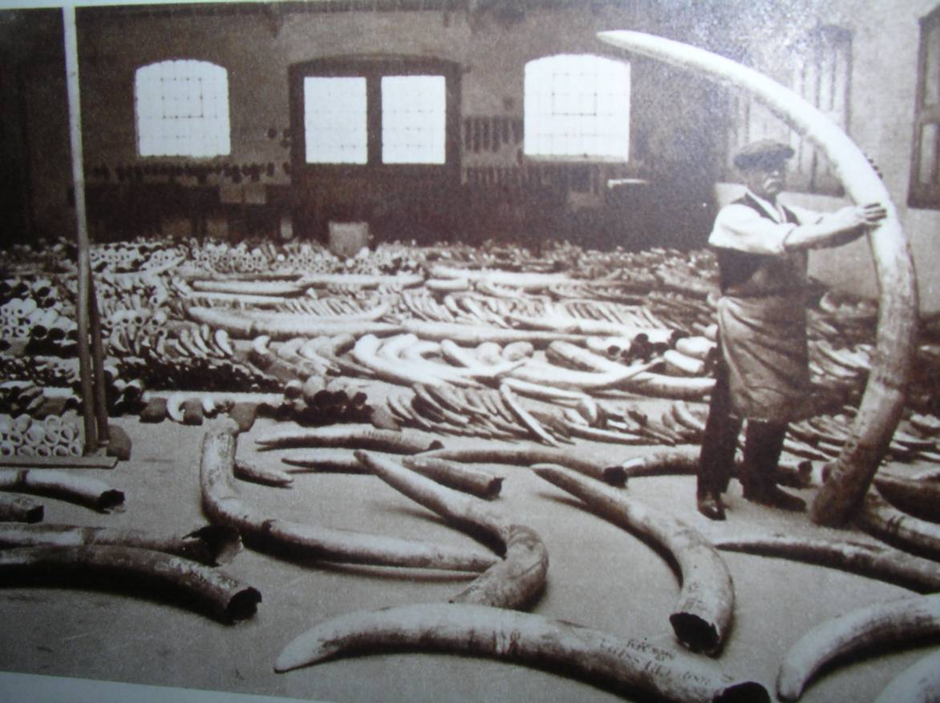

Exhibit 6: An African barter market
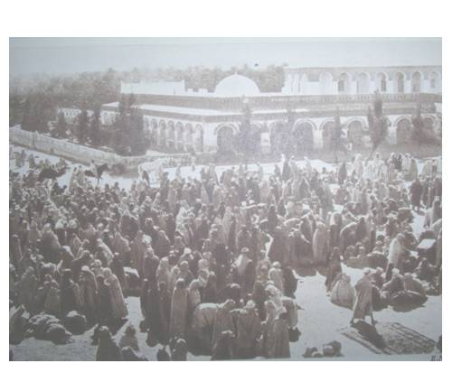
Exhibit 7: Dwellers around Mount Kenya, practise pottery and weaving and cultivate soil with domestic animals.
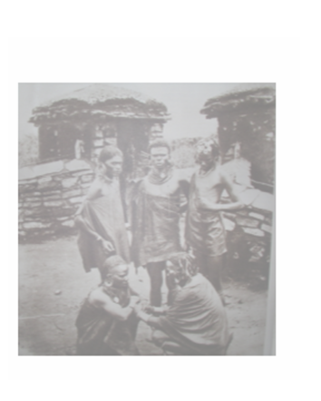
Exhibit 8: The Somali Fuzzy-Wuzzy card players. They kept camels goats and sheep and were expert card players. They also played cards.
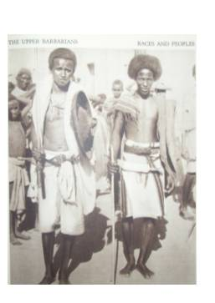
Exhibit 9: Zulu girls use decorative jewellery beads and metal bands to look beautiful
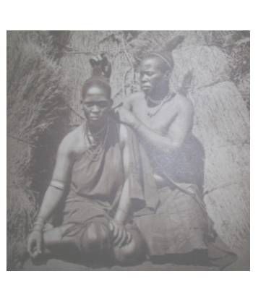

Exhibit 10: Wireless communication ‘Bush telegraph’ Villages many miles away can pick out clearly, messages tapped on these talking drum.
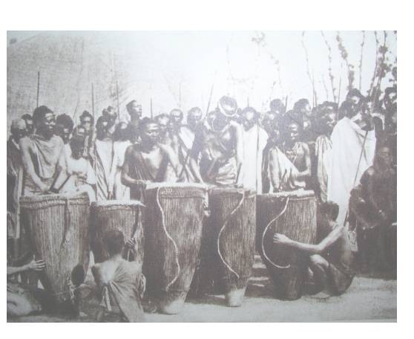
Exhibit 11 : The Oba of Oyo, Nigeria with his Council of Chiefs. Note the Chief Security Guard sitting at the front to keep order and intruders out.
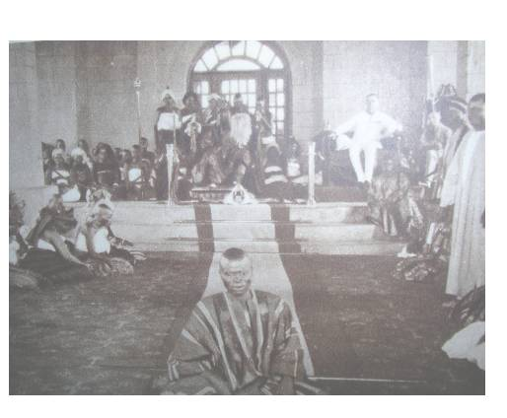
Exhibit 12: The Ibibio Boys dancers of Nigeria erroneously referred to as South African Dancers
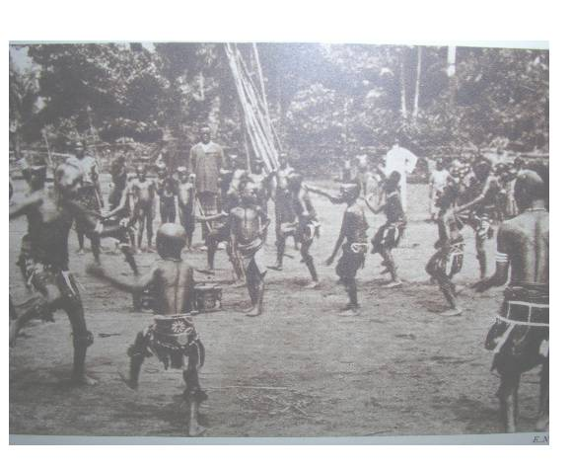
Exhibit 13: Pottery Engraving in Southern Nigeria. Note the elaborate patterns created by the craftsman using very simple tools.
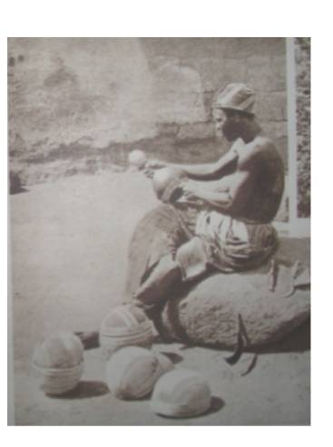

Mr Jack Smith’s defence

Mr. Smith’s defense plea could include the following:
- Needed to make a better life for self and family
- Set up education systems by building schools for local people
- The natives spoke different languages so introduced a monolingual system for easier communication
- Built roads and railways which aided transport and communication
- Introduced new technologies like trains and ships for trade
- Set up hospitals and health care systems in place of local beliefs; thereby reducing unnecessary number of deaths
- Provided paid employment for local people
- stopped tribal wars, which were leading to instability and poverty for the local people
- Set up democratic systems of government which were more representative
Photographic evidence which exist on these points are patronising and therefore have not been included, Mr Smith could however use witness accounts.
Sample questions to which answers should be prepared before the trial begins.

- What was your reaction when you first set eyes on the rainforest?
- What did you gain by hacking through the rainforest?

- Why have you got all these elephants tusks in your store room?

- What happened to the elephants after you took the tusks off them?

- As a colonialist, name three African kingdoms that you know?

- How would you describe the African Market in the photograph? Would you say this picture shows a society ‘without history’? Tell us more.

- What things have you bought from an African market and how did you go about this?

- Look at these Zulu girls they clearly like dressing up and looking good, they look very fashionable I would say. Why did you describe them as ‘without culture?

- How would you describe what this weaver and his wife are doing? Does the word ‘lazy’ describe them? why did you describe the indigenous people as lazy?

- How useful would you describe the African talking drums to the people? Why did you describe the people as without industry?

- Why did you replace the local ruling systems with your own?

- If your country was so great why did you have to emigrate to others?

- The indigenous people welcomed and respected you, believing in your god, why you did you treat them so badly?

- Is it true to say that you only colonised these places to make money? Explain your answer.

- Describe a project you undertook to give back some of the money you made to the local people

- Have you heard of the word ‘racist’ and does this word describe you and your actions?

The presiding judge (the teacher or other adult) must keep reiterating points made during the trial; to draw out the learning and lessons coming out

After the trial, students should work individually to write their persuasive argument about the verdict; starting their argument with e.g. ‘After considering all the evidence, I believe that Mr Smith is guilty / not guilty for the following reasons:’
Resources

- A large hall or room to conduct the trial
- Props for the missionary / colonialist e.g. a bible, a crucifix, a rosary, a cross, a portmanteau
- props for the colonialist – bowler hat, umbrella, a couple of books, map of the world, British flag etc
- Accounts and books of early travels round the world
- world history books
- world history encyclopaedia
- World map
- world globe
- Interactive whiteboard or a projector to show the photographic evidence
- Pens and paper for the students to take notes

Persuasive argument phrases that could be used

I believe that

Although some people would argue that ….., in my opinion this is ….

My first reason is that the evidence that was presented on that charge clearly show that …..

After considering the evidence that … I would argue that ….

Furthermore …

Another reason is …

I also believe that …

…. any other verdict would be a miscarriage of justice

In conclusion therefore I urge the jury to find the defendant guilty / not guilty on the indictments

