Name:………………………….. Date:………………..
WALT: Recognise lines of symmetry
Can you see any lines of symmetry in any of these world cup country flags?
(Think carefully about the colours used on the flags)
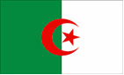  Algeria | 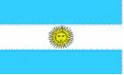  Argentina | 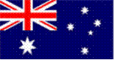  Australia | 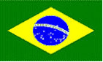  Brazil
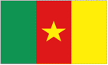  Cameroon | 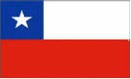  Chile | 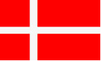  Denmark | 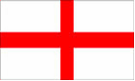  England
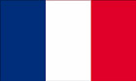  France | 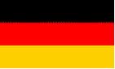  Germany | 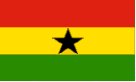  Ghana | 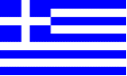  Greece
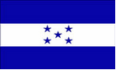  Honduras | 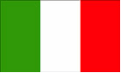  Italy | 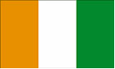  Ivory Coast | 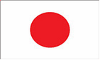  Japan
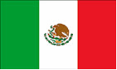  Mexico | 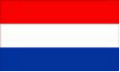  Netherlands | 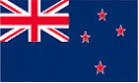  New Zealand | 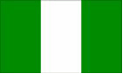  Nigeria
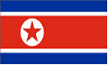  North Korea | 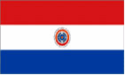  Paraguay | 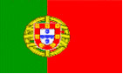  Portugal | 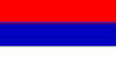  Serbia
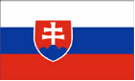  Slovakia | 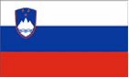  Slovenia | 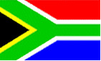  South Africa | 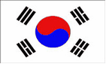  South Korea
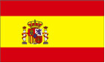  Spain |   Switzerland | 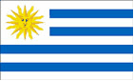  Uruguay | 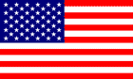  USA

