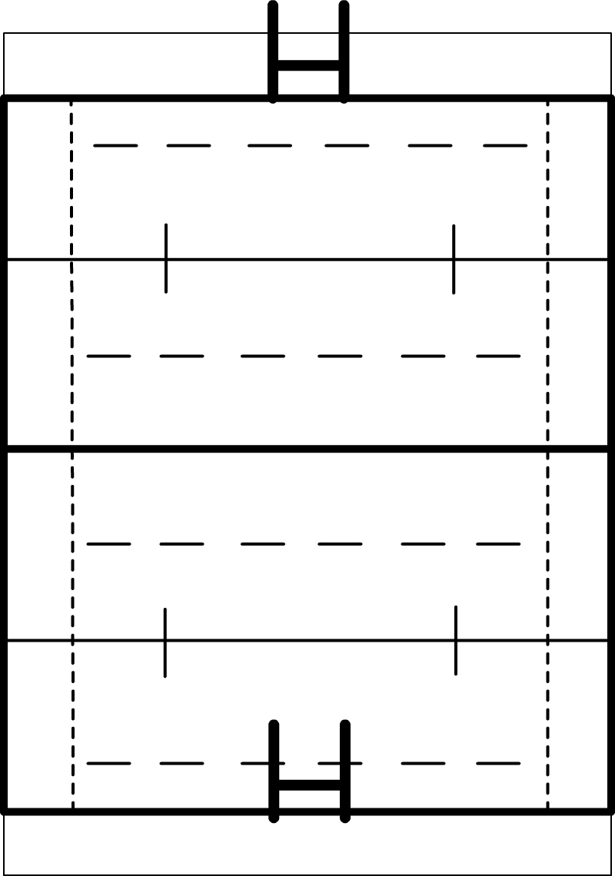
Rugby Pitch Maths
width
length
Rugby pitches aren’t all the same size!
The length mustn’t be bigger than 100 meters and the width mustn’t be bigger than 70 meters.
- What is the perimeter of the maximum size of rugby pitch?
- What is the area of the maximum size of rugby pitch?
- On the biggest possible pitch a player runs from under his posts to the halfway line, then runs back to the posts where he started and then finally runs all the way to the opposite posts. What is the shortest distance he will have travelled.
- A rugby pitch has an area of 5400 m². What could the dimensions of the pitch be?
- A club tactically decides to narrow the width of their rugby pitch in order to make it easier for their players to defend. The original width of their pitch was 65 m with a length of 90 m. The new width is 55m. How much smaller is the new area of the pitch?

Extension Task
The spaces behind each set of flag posts are called the in-goal areas. According to the rules, each of these should extend no further than 22 meters behind the posts.
If you include the size of these sections then what would be the total area of a maximum-sized rugby pitch?

